Item No:

0

Committee: Audit and Governance

Date of Meeting: 18 March 2024

Subject: Corporate Risks Update

Report Author: Audit Manager

Contact Officer: Kanchan Vasisht

Implications: Legal  Community Safety

Equalities  Environment

Financial  Consultations

Staffing  Other

Wards Affected: None

**Purpose**

1. To provide an update on the authority’s corporate risks and the risk management work being undertaken.

**Recommendations**

1. **The Committee is recommended to:**
2. **Consider the findings from the World Economic Forum on current and emerging global risks; and how these align with the risks currently reported within the Corporate Risk Register.**
3. **Review the council’s risk appetite statement to ensure it remains current.**
4. **Review the updated Corporate Risk Register.**

**Background**

1. This report provides an update of the authority’s corporate risks, to assist the committee in fulfilling their obligations to periodically review the authority’s Corporate Risk Register and to consider the effectiveness of the council’s risk management arrangements.
2. The council’s Risk Management Strategy provides a framework to ensure that risks and opportunities are managed effectively, which is also an essential part of good corporate governance. The strategy is designed to strengthen, support and embed risk management across the council to ensure opportunities are maximised; there is effective delivery of services; and objectives are met, including the achievement of the strategic priorities set out in the Corporate Plan to deliver the Luton 2040 vision. It reflects current thinking, best practice and the value of well-recognised principles for risk management. The strategy is regularly reviewed and updated in line with the council’s developing needs and requirement.
3. All risks are recorded on the council’s risk management system, and are assigned to Risk Owners for review and monitoring. The system issues automatic reminders for Risk Owners to update their risk assessments and control measures when they become due for review. E-learning training on risk and how to use the system is available to Risk Owners. Risk management training is delivered corporately to Officers and Members. New members of staff who have been assigned risks also receive risk management training on a one to one basis.
4. Corporate risks are reported to the Internal Governance Group, Corporate Leadership Management Team, and Audit and Governance Committee for review on a quarterly basis.

**Report**

**The Global Risk Report 2024**

1. In September 2023, the World Economic Forum carried out a Global Risks Perception Survey (GRPS), which captured insights from nearly 1,500 experts on global risks. The key findings from this survey are noted in The Global Risk Report 2024, which can be accessed via the following link: <https://www.weforum.org/publications/global-risks-report-2024/digest/>. The report analyses global risks through three timeframes to support decision makers to balance current crises and long term priorities.
2. The results from the survey highlight a negative outlook for the world over the next two years, which is expected to worsen over the next decade. The extracts from the report below provides details on the current risk landscape (figure b); and the global risks ranked by severity over the short term and long term (figure c):

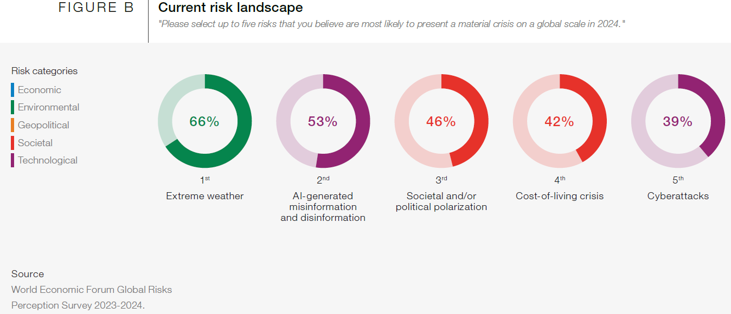

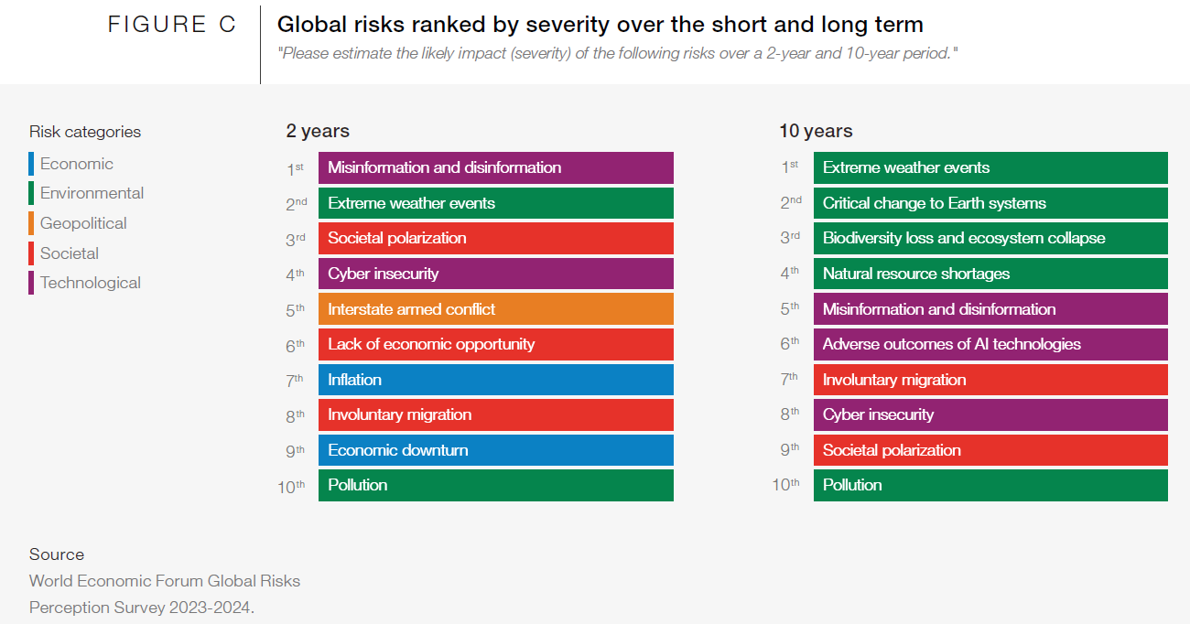

1. The report highlights that:

* Environmental risks, in particular extreme weather events, dominates the risk landscape in all three timeframes.
* Societal polarization features among the top 3 risks over both the current and 2 year timeframe.
* The cost of living crisis and cyber-attacks remain as major areas of concern for 2024.
* Technological risks, in relation to misinformation and disinformation, is considered to be a major area of concern for 2024 and seen as the most severe global risk emerging within the next 2 years.

1. A comparison of the above global risks to the risks reported within the Council’s Corporate Risk Register (attached at Appendix B) identified that the register currently includes:

* Two medium-high priority risks on climate change (Risk Ref. LBC0084 and LBC0093).
* Societal polarization features in the medium-high priority risk on deterioration in community cohesion (Risk Ref. LBC0088).
* The cost of living crisis features in the high priority risk on failure to keep to approved budget (Risk Ref. LBC0006).
* There is a medium-low priority risk on cyber-attacks (Risk Ref. LBC0098).

1. Further details of these corporate risks and the control measures in place to manage these risks are provided in the table below.

| **Risk ref** | **Risk details** | **Control measure update** |
| --- | --- | --- |
| LBC0084 | Failure to achieve the emission reduction target of 2040 of net zero carbon. | Medium-High Priority Risk.  The Executive formally adopted the Luton net zero roadmap and policy on 24 July 2023. The Roadmap provides key guidance on how the town can work towards becoming net zero by 2040; it outlines key milestones; and wider stakeholder engagement needed to achieve the targets for the borough.  A Head of Climate Change and Climate Action Project Officer have been appointed.  New Terms of Reference for the Climate Change Advisory Group have been agreed and roles assigned to each member to take the lead.  Formal links with Inclusive Economy Board established for system partners’ engagement, reporting and potential joint delivery.  Internal Net Zero Delivery Group formed to increase services’ accountability and focus on delivery.  Significant progress has been achieved on a range of projects across the Council, for example:   * £34m investment programme into insulating council properties. * £7.7m investment in 16 schools and public buildings to provide IoT lighting, heat pumps and PV panels. * 98% of street lights have been converted to LEDs. * Investment in liquid to gas biofuel for council fleet. * Increased green spaces and tree cover ambition. * Raising climate change awareness. An e-learning module has been developed for council staff and elected members. A Climate Change Guide for residents and refreshed advice for home energy improvements have been published on the council’s website. * 12 schools have been supported to develop Climate Action Plans. * Capacity building programmes for businesses and community groups underway – these should increase knowledge of net zero and facilitate further action plans. * Support for community energy schemes secured until March 2025. |
| LBC0093 | In the event of a failure to limit the causes, prioritise action and allocate resources, and to prepare for the effects, of the climate crisis at a local, national and international level, there is an increased risk to Luton of extreme weather events that may significantly disrupt our ability to deliver services, damage the council’s reputation, lead to further financial challenges and ecological and environmental impacts for future generations. | Medium-High Priority Risk.  The Council is a Lead Local Flood Authority, and works in partnership with the Environment Agency and water companies to manage the risk of floods and to deliver flood mitigation schemes.  A Local Flood Risk Management Strategy is in place to improve the understanding of flood risks in Luton; consider mitigation; and to provide emergency planning, response and resilience when flooding incidents occur.  The Luton Net Zero Climate Policy and Action Plan includes a section on biodiversity and resilience. This includes actions such as:   * Continuing to apply for government funding for flood and water management. * Emergency preparedness for extreme weather events. * Working with the community to raise awareness and manage risks of flooding. * Identifying tree planting opportunities to increase tree cover.   Flood risk projects in delivery – Sustainable Drainage in schools (2 locations), River Lea Linear Park, Open Lea 2 (culverts and flood risk in town centre).  Officers are part of regional (East of England) and cross-sectoral (NHS/public health led) working groups on climate change adaption assessing preparedness, analysing gaps and lobbying for more resource from government. |
| LBC0088 | Deterioration in community cohesion. | Medium-High Priority Risk.  Reviewed in line with the new Social Justice Unit structure and service plan 2023-2024.  New Fairness Strategy developed and published in current year.  Ongoing tension monitoring regularly conducted with the Police.  New Community Safety Partnership Plan 2024-2028 is in production to address threats, harms and risks in partnership. |
| LBC0006 | Failure to keep to approved budget, particularly re: demand-led services, new requirements, savings targets, inflationary pressures on both price and pay, budget pressures due to demographic changes, loss of income and the aftermath of Covid-19 on the Council and Luton Rising. | High Priority Risk.  The ability to increase Council Tax by 5%, a modest increase in Grant Funding combined with prudent financial management following the July 2020 emergency budget has allowed the Council to set a balanced General Fund Revenue budget for 2024/25.  However delivering this is subject to specific challenges and risks.  The following mitigation plans and regular monitoring, reporting with corrective measures should assist the council to deliver a balanced budget this year.   * Preparation and delivery of a deficit recovery plan and this year’s new savings. This is proving to be a challenge because of the cost of living crisis, inflation, high interest rate, and other macroeconomic factors. * No additional commitments without identification of funding sources. * Delivery of the income target as approved by Council. * Exit strategy for commitments whereby funding was available on a one-off basis. * Active demand management and preventative measures put in place at the outset. * Close monitoring of inflation and increases in interest rates and impact on both revenue and capital budget and corrective measures put in place. * Close monitoring of council tax and business rates collection rates, commercial income and housing benefits payment. * Working with Human Engine and with other departments on the Council’s Transformation Programme to identify savings to bridge the current core deficit and future budget gap in order to deliver an affordable and sustainable medium term financial plan. * A moratorium on engagement of Agency Staff for most Services, unless approved by Chief Officers. |
| LBC0098 | As a result of a cyber-attack (e.g. ransomware) Council data is ex-filtrated by criminals, and confidential data is published. | Medium-Low Priority Risk.  Implementation of Cyber Security Strategy.  The risk position around cyber is regularly monitored through the Information Security Board. |

1. At the time of comparison, there was no corporate risk on misinformation and disinformation. As this is seen as a major area of concern for 2024 and the most severe global risk emerging in the next 2 years the following new risk has been added to the Corporate Risk Register. This risk will continue to be reviewed and monitored, as the risk likelihood is expected to grow.

| **Risk ref** | **Risk details** | **Control measure update** |
| --- | --- | --- |
| LBC0102 | Misinformation / Disinformation through Fraudulent Impersonation.  *Inherent Risk Score = 6*  *(Medium-High)*  *(Likelihood 2 x Consequences 3)*  *Residual Risk Score = 4*  *(Medium-Low)*  *(Likelihood 2 x Consequences 2)* | New risk identified through Horizon Scanning – monitoring the situation as the risk likelihood is expected to grow. |

1. The committee is recommended to consider the findings from the World Economic Forum on current and emerging global risks; and how these align with the risks currently reported within the Corporate Risk Register (attached at Appendix B).

**Risk Appetite Statement**

1. The effective management of risks is an essential part of good corporate governance. For a risk management process to be effective it is important that an organisation has clearly defined its risk appetite and the level of risk / type of risk it is willing to take in order to achieve its objectives.
2. A well-defined risk appetite statement would:

* Provide clear and consistent guidance, and assurance to Members and the public that the council is aware of and managing its risks.
* Assist to make informed decisions.
* Identify resources being deployed on risks that we are prepared to tolerate and re-focus them on risks that are more business critical.
* Define the thresholds above which risks should be escalated and monitored more frequently.

1. In June 2022, Zurich Municipal (ZM) were commissioned to assist the council to develop and expand its risk appetite statement. ZM engaged with Senior Officers and Members for their views on risk via a survey and workshop in order to develop the council’s risk appetite statement. They explored nine categories of risk in the acknowledgement that there will be different attitudes to what risk is. This subsequently led to the development of the following risk appetite statements for each category of risk; and an overall risk appetite statement.

*Risk Appetite by Category:*

| **Risk Category** | **Risk Appetite** | **Statement** |
| --- | --- | --- |
| Political | Open to Risk  (Medium High) | With the context we’re in and to fulfil our ambitions, we are willing to push the boundaries of political risk in order to deliver exceptional results. Even if it puts a significant part of strategic or political objectives at risk, the potential gains outweigh any possible losses. |
| Economic / Financial | Open to Risk  (Medium High) | We will actively seek financial and economic investment and subsequent gains, even if we risk financial losses, where clear benefits can be evidenced. We must manage the risk to a tolerable level, but be unafraid to seek out opportunities. |
| Social | Open to Risk  (Medium High) | We will accept some risk to the short-term resilience of the organisation and community, when longer term benefits are deemed to outweigh short term risk. |
| Technological | Cautious with Risk  (Medium Low) | We want to ensure we have the technology to support people to deliver great services by taking a cautious approach to new systems. We will take every precaution that these can fulfil requirements before embarking on implementation of new technology. |
| Legislative | Cautious with Risk  (Medium Low) | We will err on the side of caution regarding interpretation of legislation. However, we are willing to be more open to risk taking within our legislation to support wider objectives and vision when we have an appropriate understanding of existing case law and the risk that follows from our actions. |
| Climate Change & Environmental | Cautious with Risk  (Medium Low) | We are prepared to accept a higher level of risk of increasing our environmental impact in order to pursue our wider strategic objectives. However, these risks should be accompanied by strong mitigation and control factors that underpins our commitment to improving the local environment and reducing the environmental impact of council activities. |
| Customer / Citizen | Cautious with Risk  (Medium Low) | We will accept some risk of reduced ability to serve our customers in individual areas, when seeking to address their future needs. Initiatives must address the possibility that new ways of providing services might not suit all citizens and provisions must be made to accommodate that. |
| Partnership / Contractual | Open to Risk  (Medium High) | Partnerships are essential to achieving our objectives and we will pursue relationships for the best outcome of our residents and positively drive the Luton 2040 agenda. |
| Reputational | Reputational risks were also discussed. However, through review of feedback from initial draft reports, it was decided to leave out reputation as a separate risk category. Reputational risk is crosscutting and the reputational impacts should instead be considered as part of the risk analysis for risks across all categories. | |

*Overall Risk Appetite Statement:*

|  |
| --- |
| The council is open to a certain amount of risk in pursuing initiatives to support both high ambitions and the reality of existing in volatile and changing environment. The council will be cautious to make sure that risks are within the council’s capability to manage them and has the capacity to withstand negative impacts. |

1. Further details on the work undertaken by ZM and the development of the council’s risk appetite statement is noted in ZM’s report attached at Appendix A. Since then, these statements have been approved by this Committee; and have also been incorporated within the Council’s Risk Management Strategy.
2. The Committee is recommended to review the risk appetite statements to ensure they remain current.

**Corporate Risk Register**

1. The council uses the 4X4 Risk Assessment Matrix (grid below) to assess both the likelihood of a risk occurring and the impact on the council in the event that it did occur.

1. The risk is scored twice, an initial assessment, known as the *inherent risk*, and a further assessment, known as the *residual risk*, after considering the controls and mitigation the council already has in place. The criteria used to assess the likelihood of a risk occurring and consequences is detailed in the table below. The overall risk score is calculated by multiplying the impact score by the likelihood score.

|  |  |  |  |
| --- | --- | --- | --- |
| **Score** | **Description** | **Likelihood**  **(short to medium term)** | **Consequences / Impact**  **(i.e. impact on strategy, operations and financial implications)** |
| 4 | High | Highly likely to happen many times. | Cannot deliver much of the strategy.  Long term disruption of most operations.  Loss of most useable Council reserves. |
| 3 | Medium - High | Likely to happen several times. | A significant part of the strategy not delivered.  Long term disruption or a few short term disruption of many operations.  Loss of over 50% of Council reserves. |
| 2 | Medium - Low | Unlikely to happen more than occasionally. | Elements of the strategy not delivered. Short term disruption of a few operations.  Loss of 25% of Council reserves. |
| 1 | Low | Unlikely to happen. | Trivial and / or short term impact on reserves, strategy and operations. |

1. The second risk assessment (*residual risk*), taking the controls into consideration, predominantly lowers the risk score but sometimes it can remain the same. The 4Ts of risk management summarises the different strategies that can be used to manage risk: Tolerate; Terminate; Treat; and Transfer.

|  |  |
| --- | --- |
| **Tolerate** | Accept the risk.  Risks that are accepted still need to be monitored and reviewed. |
| Terminate | Eliminate the risk, i.e. by terminating the activity or doing things differently. |
| Treat | This is the most widely used approach.  Reduce the impact and likelihood of the risk occurring through effective control measures. |
| Transfer | Transfer the implications of the risk to a third party, i.e. insurance. |

1. There are currently 37 risks on the Corporate Risk Register. Since the last update the following 2 risks have been withdrawn from the register and 1 new risk added.

*Risks Withdrawn:*

| **Risk ref** | **Risk details** | **Comments** |
| --- | --- | --- |
| LBC0097 | Risk of severe business disruption as a result of a cyber-attack (e.g. ransomware). | Risk withdrawn, as this is a duplication in cyber risk: As a result of a cyber-attack (e.g. ransomware) Council data is ex-filtrated by criminals, and confidential data is published (Risk Ref. LBC0098). |
| LBC0099 | There is a risk that the council will suffer financial loss or reputational damage as a result of email phishing, or social engineering.  For example; staff being duped into paying false invoices, or false changes of bank details to pay vendors or staff. | Risk withdrawn, as this is a duplication in cyber risk: As a result of a cyber-attack (e.g. ransomware) Council data is ex-filtrated by criminals, and confidential data is published (Risk Ref. LBC0098). |

*New Risk added to the Corporate Risk Register:*

| **Risk ref** | **Risk details** | **Comments** |
| --- | --- | --- |
| LBC0102 | Misinformation / Disinformation through Fraudulent Impersonation.  *Inherent Risk Score = 6*  *(Medium-High)*  *(Likelihood 2 x Consequences 3)*  *Residual Risk Score = 4*  *(Medium-Low)*  *(Likelihood 2 x Consequences 2)* | New risk identified through Horizon Scanning – monitoring the situation as the risk likelihood is expected to grow. |

1. Appendix B provides details of the corporate risks; the (4x4) residual risk scores; and the direction of travel for each risk since the last update. A review of the direction of travel indicates that the risk prioritisation appears to have:

* Remained the same for 34 risks.
* Reduced for 1 risk.
* Increased for 1 risk.
* For 1 risk it is not applicable, as this is a new risk added to the register.

1. Further details of the 2 risks where the prioritisation has changed is provided in the table below.

| **Risk ref** | **Risk details** | **Comments** |
| --- | --- | --- |
| LBC0062 | Failure to act appropriately following receipt of a safeguarding alert in line with multi agency procedures for safeguarding alerts leading to death or serious harm to an adult at risk. | Safeguarding concerns received are being processed and actioned in accordance with our local measures. There are strategies in place to enable improved reporting and analysis.  A review of the control measures in place has resulted in a reduction in the residual risk score from 9 (Medium – High) to 6 (Medium – High). |
| LBC0075 | Failure to comply with data protection legislation risks enforcement action and possible fine, along with adverse publicity and civil action by data subjects. | There have been breaches within the last year that have been reported to the ICO.  This has resulted in the residual risk score increasing from 4 (Medium – Low) to 6 (Medium – High). |

1. The heat map (4x4 matrix) below plots the residual risk scores for each corporate risk, based on the likelihood of it occurring and the impact on the council in the event that it did occur, to provide an overview of the council’s risk landscape. The heat map shows that the greatest number of risks are currently assessed by Risk Owners as medium-high priority, and 4 risks have been assessed as high priority. The risks have been plotted according to their risk reference numbers. Further details on the corporate risks are provided in Appendix B.



1. Details of the 4 high priority risks and an update on the control measures in place to manage these risks is provided in the table below.

| **Risk details** | **Control measure update** |
| --- | --- |
| Failure to keep to approved budget, particularly re: demand-led services, new requirements, savings targets, inflationary pressures on both price and pay, budget pressures due to demographic changes, loss of income and the aftermath of Covid-19 on the Council and Luton Rising.  (Risk Ref. LBC0006)  *Inherent Risk Score = 16 (High)*  *(Likelihood 4 x Consequences 4)*  *Residual Risk Score = 12 (High)*  *(Likelihood 3 x Consequences 4)* | The ability to increase Council Tax by 5%, a modest increase in Grant Funding combined with prudent financial management following the July 2020 emergency budget has allowed the Council to set a balanced General Fund Revenue budget for 2024/25.  However delivering this is subject to specific challenges and risks.  The following mitigation plans and regular monitoring, reporting with corrective measures should assist the council to deliver a balanced budget this year.   * Preparation and delivery of a deficit recovery plan and this year’s new savings. This is proving to be a challenge because of the cost of living crisis, inflation, high interest rate, and other macroeconomic factors. * No additional commitments without identification of funding sources. * Delivery of the income target as approved by Council. * Exit strategy for commitments whereby funding was available on a one-off basis. * Active demand management and preventative measures put in place at the outset. * Close monitoring of inflation and increases in interest rates and impact on both revenue and capital budget and corrective measures put in place. * Close monitoring of council tax and business rates collection rates, commercial income and housing benefits payment. * Working with Human Engine and with other departments on the Council’s Transformation Programme to identify savings to bridge the current core deficit and future budget gap in order to deliver an affordable and sustainable medium term financial plan. * A moratorium on engagement of Agency Staff for most Services, unless approved by Chief Officers. |
| Failure to recruit/retain staff (i.e. potentially losing top performing staff due to competitiveness of salary package in some sectors).  (Risk Ref. LBC0008)  *Inherent Risk Score = 16 (High)*  *(Likelihood 4 x Consequences 4)*  *Residual Risk Score = 12 (High)*  *(Likelihood 3 x Consequences 4)* | Developed a new People Strategy and implementation plan. Recruitment and retention will be central to this, including a review of the Employee Value Proposition (EVP). Following discussion at CLT a plan is now being executed to secure a new EVP, stabilising an internal recruitment team and moving ahead with a range of actions on key issues identified in the staff survey like pay.  Review Summary: Risk score remains the same. Mitigations are being put in place including a business case for the modernisation of the recruitment service. |
| The current demand profile/poverty in Luton continues to result in an overspend on the agreed budget.  (Risk Ref. LBC0071)  *Inherent Risk Score = 16 (High)*  *(Likelihood 4 x Consequences 4)*  *Residual Risk Score = 12 (High)*  *(Likelihood 3 x Consequences 4)* | Budget Monitoring.  Luton 2040 agenda.  Review Summary: The numbers of households in temporary accommodation is monitored regularly, however, the demand pressures, which have seen an average of 460 homeless households approach the Council for assistance has had an adverse impact on the reduction plan.  Hotel numbers rose to 117 but has been reduced to 70, although overall numbers of temporary accommodation is 1,043.  The target will be missed this year and will be re-profiled for next year.  Additional work is taking place with our transformation partner, Human Engine to bring more oversight to the challenges being faced. |
| Failure to improve the decline and look of the town centre.  (Risk Ref. LBC0085)  *Inherent Risk Score = 16 (High)*  *(Likelihood 4 x Consequences 4)*  *Residual Risk Score = 12 (High)*  *(Likelihood 3 x Consequences 4)* | Town Centre Development Framework.  Town Centre Strategic Board.  Masterplan and Delivery Plan.  Masterplan Project Board meet monthly.  Developing IPM Place Metrics for prioritisation of delivery and funding.  Monthly IE DMT Updates with key internal Directors.  Review Summary: Whilst there have been recent positive developments, including the new pocket park being opened, a contract has been awarded for the LUF scheme, and UKSPF money secured for public realm improvements. These still represent a small portion of the town centre and their impact has not been fully realised.  The Football Club promotion is also likely to help the delivery of the new football stadium with the club quoting 2026 delivery. This achievement has raised Luton’s profile nationally and led to informal inquiries about wider investment.  The Mall has now been acquired with the Fraser Group and the council is in discussions with them on their long term strategy. This is likely to see an improved uptake of vacant units in the short term (albeit, we have less vacant units than the national average).  The new town place brand is to launch shortly and is to help promote the town and change incorrect perceptions. This is expected to improve local footfall and spend.  The underlying fundamentals, recent economic turbulence and external environment remain extremely challenging. Until inflation settles and values improve, town centre decline is a high risk. Recent continued uncertainty to interest rates, as inflation stays higher than predicted levels, has hurt investor confidence.  The council has recently set up a developer forum to bring together property developers to best work with the market on delivering the right homes and the right quality to the town and town centre. |

**Appendices**

1. The following appendices are attached to this report:-

Appendix A – Zurich Municipal Risk Appetite Report

Appendix B – Luton Council Corporate Risk Register Update

**List of Background Papers - Local Government Act 1972, Section 100D**

1. (a) Corporate Risk Register

(b) The Global Risk Report 2024

(c) Zurich Municipal Risk Appetite Report

Implications

| Item | Details | Clearance Agreed By | Dated |
| --- | --- | --- | --- |
| Legal | The Accounts and Audit Regulations 2015 places an obligation on local authorities to maintain a system of internal audit whereby it:  *3(a) facilitates the effective exercise of its functions and the achievement of its aims and objectives;*  *(b) ensures that the financial and operational management of the authority is effective; and*  *(c) includes effective arrangements for the management of risk.*  5(1) The relevant authority must undertake an effective internal audit to evaluate the effectiveness of its risk management, control and governance processes, and take into account public sector internal auditing standards or guidance.  6(1) Each financial year the council must conduct a review of the effectiveness of the system of internal control required by regulation 3 (see above) and prepare an annual governance statement.  This report addresses the statutory obligations for local audit processes in compliance with the 2015 Regulations in particular with regard to the requirement for the Council to have in place arrangements for the management of risk. | Elaine Addy  Childcare Solicitor | 28.02.2024 |
| Finance | There are no financial implications to this Report other than those set out in the body of this Report. | Dev Gopal  Service Director Finance, Revenues and Benefits | 29/2/24 |
| Equalities |  |  |  |
| Environment |  |  |  |
| Community Safety |  |  |  |
| Staffing |  |  |  |
| Consultations |  |  |  |
| Other |  |  |  |