Directorate | Children, Families & Education
Combined Tracker Ref.
Service Director | Teresa/Hills & Teresa Gallagher
Service Area | Children’s Placements
Service Manager
Activity/Cost centres | All Placements Cost Centres
22/23 Budget £’000 | 18,473
22/23 Outturn £’000 | 18,839
23/24 Budget £’000 | 20,008
Pressure on this activity in 23/24 (based on 22/23 outturn) £’000 | - £1.557m projected overspend variance in Children’s placements plus further £1.1m overspend in children with disability area (home support, shared care service and direct payment) so almost £2.7m overspend being reported in Q3, 2023/24.  - £366k final outturn overspend in 22/23

Explain the context behind this pressure and what has caused it
- Since when has the budget been in deficit (provide the year, e.g. 2020/21)
- Provide details of activity levels and the key cost/income drivers and how these have changed (this is needed for each year including the year prior to when the budget was first in deficit)
These areas have seen significant budget pressures over a number of years due to the level of need and complexity of care required by families and children in the town and in response to the need to improve the quality of services. As per Q3 placements model summary:

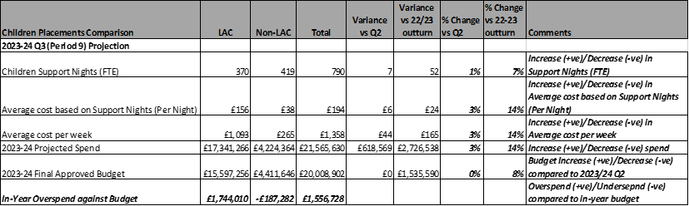

What action(s) can be taken to keep 23/24 spend in line with approved budget?
- What needs to be done? If there is more than one option explain each option in detail
- Are there any barriers or factors beyond your control that will affect your ability to recover the deficit?
- Explain how the cost/income drivers can be managed
- There were 72 children in high-cost placements.
- 58 of those are costing over £1k per week and 14 residential are costing between £3.5k to £15k per week (10 costing £3.5k per week and 4 up to £15k per week)
- Two review panels have been set on a weekly basis, starting from 17th October to 31st December 2023, to review the placement plans for all 72 children: starting with the most expensive placements in residential settings. Total projected reduction in spend because of these panels reviews is £557k out of which £460k has already been accounted for in Q3 monitoring reported in this report.
- Financial contribution from partners - A revisit of the financial contribution from health and education. However, no information is available to suggest any increase in contributions from Health or Education has been agreed towards placement costs.
- Children with continuing care needs – Strengthen the finance contribution between health and social care for those children who have continuing health care needs but again no evidence to suggest additional contributions from Health towards placement costs where there is currently no contribution has been agreed.
- A review of the purchasing of the wraparound services to support children’s care plans.
- Luton’s children’s residential Wigmore Hall to be opened by the end of Q3 which will help to reduce high-cost placements.

Timescale for budget deficit recovery
- List the key milestones required to deliver the budget recovery, the estimated amount to be delivered and the estimated date for each

MILESTONE DETAILS | £ | Date

Quarterly Monitoring updates
- Provide quarterly progress updates against milestone delivery to align with the quarterly budget monitoring reports to executive. Where milestones have not been met please provide an explanation, revised milestone dates, and how delivery can be brought back on track
- If the recovery plan cannot be delivered, THERE IS NO NEW MONEY AVAILABLE so please provide an alternative proposal as to how budgets can be realigned so that it can be considered by DMT
QUARTER 1 (to 30/06/23)
On Target ? (Yes = GREEN; Partial (e.g. milestones slipped) = AMBER, No = RED)
Provide narrative below
QUARTER 2 (to 30/09/23)
On Target ? (Yes = GREEN; Partial (e.g. milestones slipped) = AMBER, No = RED)
Provide narrative below
QUARTER 3 (to 31/12/23)
On Target ? (Yes = GREEN; Partial (e.g. milestones slipped) = AMBER, No = RED)
Provide narrative below
QUARTER 4 (to 31/03/23)
On Target ? (Yes = GREEN; Partial (e.g. milestones slipped) = AMBER, No = RED)
Provide narrative below

