Developing a Strategic Plan at Luton Council

This document sets out our key system and council corporate measures and how to use them in council strategic planning.

Content:

Luton’s Measures…………………………………………………….2

Using Measure’s in your planning……………………………….3

Luton 2040 Measures……………………………………………….4

Corporate Performance Measure………………………………10

Annual Corporate Reporting Measures……………………….11

Quarterly Corporate Performance Measures……………….12

Luton’s Vision and Measures

Luton 2040 is our system wide vision for Luton to be a place where everyone can thrive and no one lives in poverty. Our council has made this our primary mission, orientating all our work towards this goal. To help us ensure our approach is targeted in the same direction, we have developed a number of different sets of measures as illustrated and described below:



Luton 2040 Measures: 40 measures related to our 40 outcomes for 2040. These measures are designed to track long term progress over time, helping us describe how Luton will have changed by the year 2040 as a result of our system wide effort. These measures are overseen and monitored by the Luton 2040 partnership groups, changed by the Luton 2040 delivery groups and are reported on annually through the Luton 2040 progress report.

Annual Corporate Reporting Measures: These are measures which the council report on annually, highlighting important metrics that the council has oversight of. These measures are overseen by elected members and changed over time by council services. They are reported through the Annual Council Report.

Quarterly Corporate Performance Measures: These measures are in the council’s direct control to change and influence in the shorter term and give an indication of how well we are performing as an organisation. These measures are overseen by elected councillors, owned by service directors and changed through the delivery of service plans. They are reported on quarterly through the council’s corporate performance report.

Plan and service level delivery measures: Each plan should develop it’s own set of delivery measures, that will track operational performance demonstrating how the actions set out in the plan will change the dial on the relevant corporate and 2040 measures set out in this document.

Individual and team targets: Targets related to plan and service delivery level measures that are the responsibility of a team or individual to deliver. These targets are set through team and line management meetings and reported on through the check-in process.

Using the measures in your planning

To ensure the council’s work is delivering towards Luton 2040, it is important that any planning undertaken, (whether that is developing or updating a strategy, plan, service plan or team plan) should be orientated towards changing the dial on one or more of the measures within this document. Plans that seek to change the dial on measures outside of this framework should first seek prior agreement from the Council’s Strategic Hub [Luton2040@luton.gov.uk](mailto:Luton2040@luton.gov.uk)

Luton 2040

Top 6 Measures

and Outcomes

**Key:**

Yellow wedge = outcome

Coloured wedge = measure

No yellow wedge = top measure



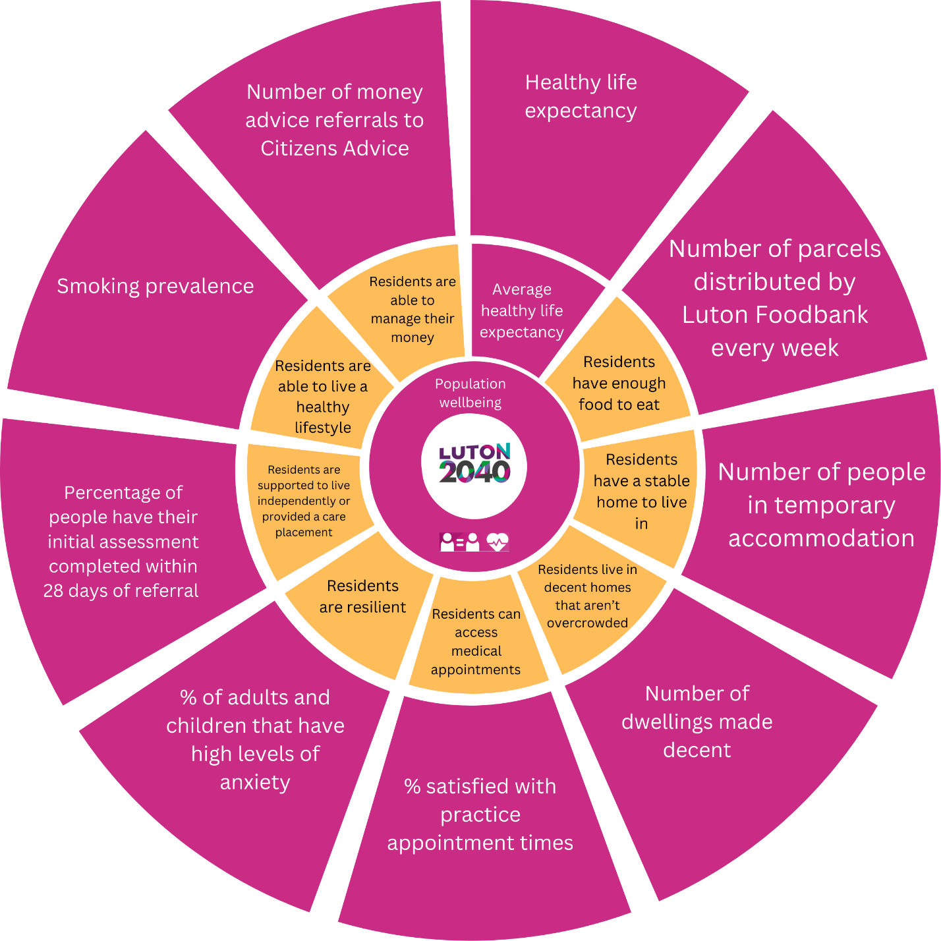2040 Population

Wellbeing

Measures

and Outcomes

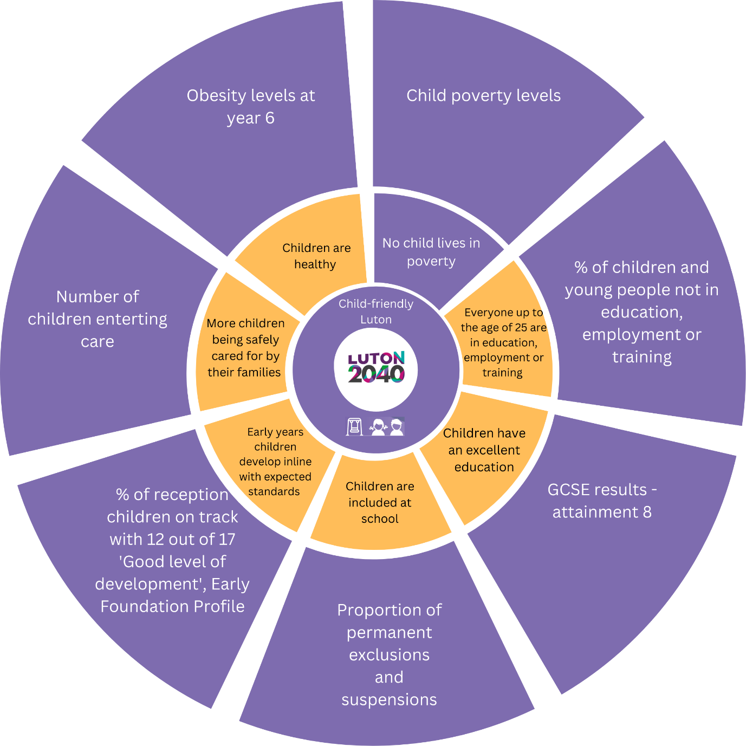2040 Child Friendly

Town Measures

and Outcomes

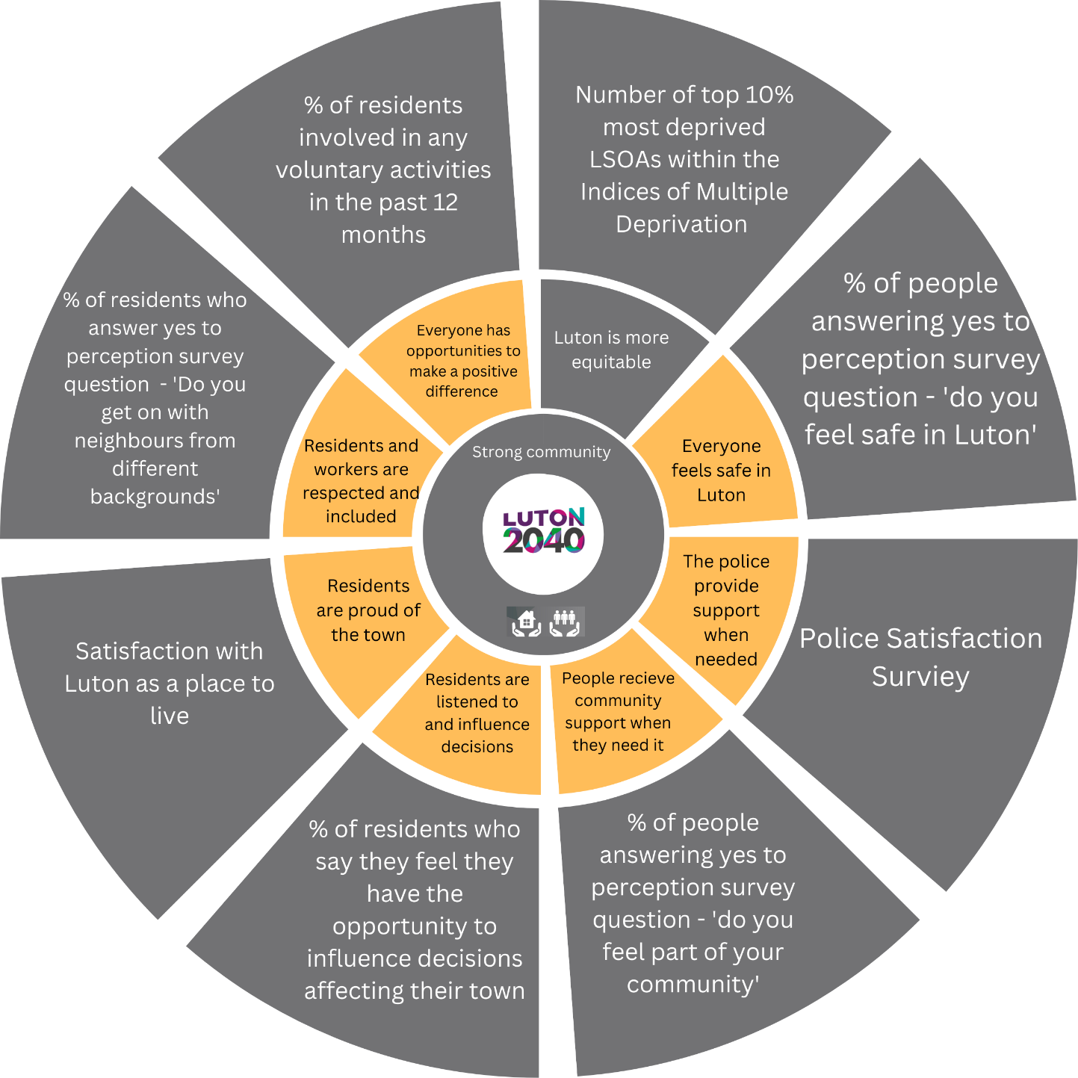Luton 2040

Fairness Measures

and Outcomes

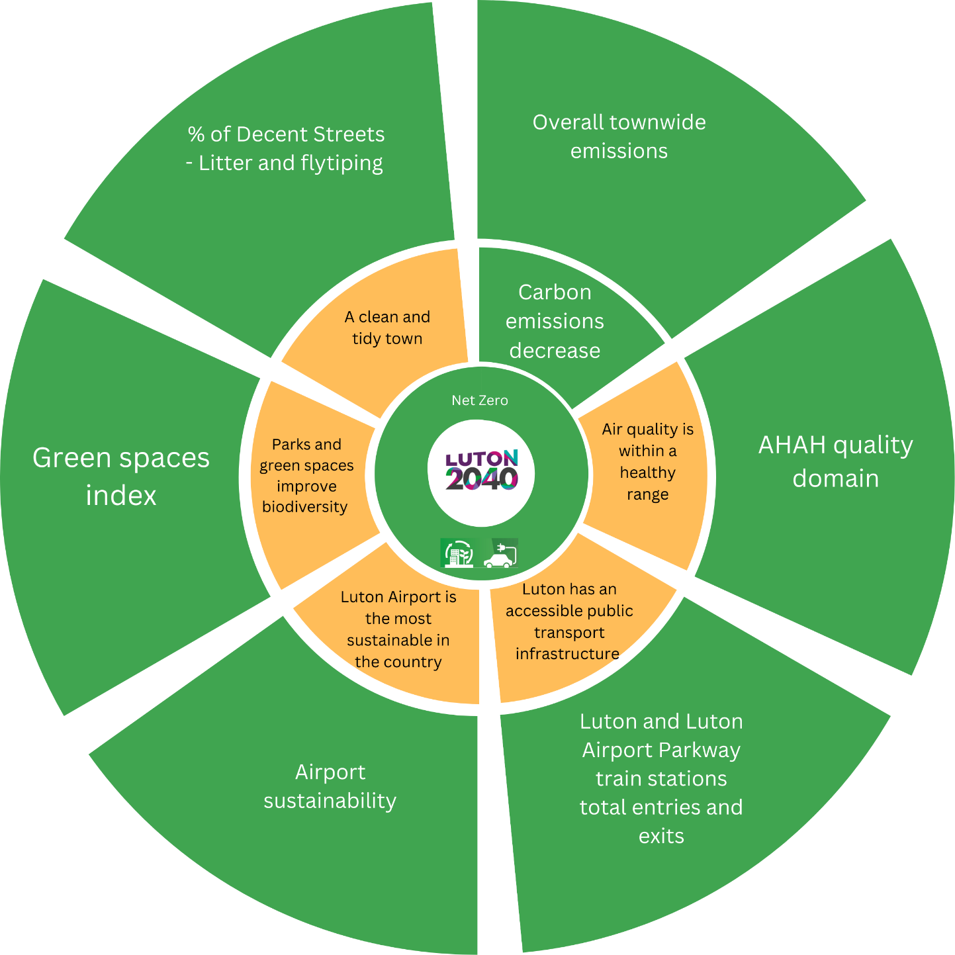Luton 2040

Net Zero Measures

and Outcomes

Luton 2040

Inclusive Economy

Measures

and Outcomes

**Corporate Performance Measures**

The measures are highlighted in the below colours to indicate which 2040 priority the measure most significantly contributes towards

|  |
| --- |
| **Child Friendly Town** |
| **Strong Empowered Community** |
| **Net Zero** |
| **Inclusive Economy** |
| **Public Health** |

**Annual Corporate Reporting Measures**

|  |  |  |
| --- | --- | --- |
|  | **What do we want to know about the impact our work is having** | **Measure to give an indication of this** |
| 1 | The quality of education provided by schools | **Measure awaiting outcome on government update of OFSTED ratings** |
| 2 | The outcomes schools achieve for children at primary stage | **Percentage of children achieving expected levels at key stage 2 reading, writing and maths.** |
| 3 | The outcomes schools achieve for children at secondary stage | **GCSE results - attainment 8** |
| 4 | Our success at providing employment opportunities for children in care | **Number of care leavers applying for council jobs and the number of care leavers getting council jobs.** |
| 5 | The quality of the care provided for looked after children | **% of children who say they are satisfied with the care provided.** |
| 6 | How successful we are at keeping children within family networks | **% of children cared for by extended family** |
| 7 | How successful we are at supporting children in care to achieve future success | **% of children in care attending higher education** |
| 8 | How successful we are at supporting children to have stable loving homes | **% of children in staying put arrangements** |
| 9 | Number of new family dwellings compared to total need from strategic housing market assessment (8500 homes over 20 years) | **Completions of all 4-person 2 bed or more homes (from the authority monitoring report (AMR))** |
| 10 | Indication of our success in supporting business growth | **Number of businesses or businesses starts up** |
| 11 | Indication of our success in influencing quality job growth | **The % of key sector jobs (aviation, advanced manufacturing, digital & creative and construction)** |
| 12 | The cleanliness of our streets | **% of Decent Streets - Litter and fly tipping** |
| 13 | Degree of contribution we are making to carbon offsetting | **% Tree canopy coverage by hector (increase by 1 hector by 2025)** |
| 14 | Reduction in car emissions through less car usage | **Meters of footpath, cycle path and no vehicle zone resurfaced or built** |
| 15 | Timeliness of adult social care response | **Percentage of people have their initial assessment completed within 28 days of referral** |
| 16 | How well we are supporting residents to stay active | **Proportion of adult population physically active** |
| 17 | Effectiveness of public health messaging | **Visible decay at age 5** |
| 18 | Are we getting lifestyle prevention right? | **Under 75 preventable mortalities** |
| 19 | How well we are supporting residents to eat healthily and exercise | **Adult obesity** |
|  |  |  |

**Quarterly Corporate Performance Measures by Directorate**

**Children Families and Education**

|  |  |  |  |
| --- | --- | --- | --- |
| **No.** | **What do we want to know about the council’s performance?** | **Measure to give an indication of this** |  |
| 1 | How inclusive schools are and how well they use support to respond to children's needs | **Number of exclusions** |  |
| 2 | **Number of exclusions in children with SEND** |  |
| 3 | How successful we are at supporting young people into employment and training | **NEET %** |  |
| 4 | Whether we are identifying children’s needs early and addressing challenges before they escalate | **Number of families requiring statutory intervention** |  |
| 5 | The stability of placements for looked after children | **% of placement changes for children in care** |  |
| 6 | Whether we are supporting children to have stable home | **% of care leavers in suitable accommodation** |  |
| 7 | The success of our early intervention for children at risk of crime | **First Time Entrance to Youth Justice System % variance change** |  |
|  |  |  |  |

**Inclusive Economy**

|  |  |  |  |
| --- | --- | --- | --- |
| **No.** | **What do we want to know about the council’s performance?** | **Measure to give an indication of this** |  |
| 8 | How swiftly we are enabling developments | **The speed with making decisions on planning application categories within the “Statutory Period”** |  |
| 9 | How good we are at getting the developments we want | **The number of appeal decisions that are allowed** |  |
| 10 | How successful we are protecting our built heritage | **Number of buildings on heritage at risk register** |  |
| 11 | The success of the support we offer people who are unemployed | **Job seeker claimant Count % compared to national** |  |
| 12 | How successful we are at spending Luton Council funding within the town | **The % of influenceable council spend through procurement spent locally** |  |
| 13 | Indication of how well we are supporting local people to pursue further skills and training | **Number of people attending adult learning courses through Adult Learning** |  |
| 14 | Vibrancy of our Town Centre | **% of unoccupied commercial and retail space in town centre** |  |
| 15 | The role the council plays in creating safe neighbourhoods | **number of enforcement actions taken** |  |
| 16 | The progress we are making on Zero Waste requirements | **Residual waste per head or household** |  |
| 17 | Provision of net zero infrastructure compared to national | **Number of new electric charge points installed as compared to national** |  |
| 18 | The role the council plays in creating clean neighbourhoods | **Number of complaints about street scene** |  |
| 19 | Resident perception of greener Luton goals | **Number of complaints about grass length** |  |
| 20 | Amount of CO2 our fleet generate | **(A) Scope 1 - Fleet fuel (tCO2)** |  |
| 21 | Carbon consumption across all corporate buildings | **Electricity and Gas consumption of corporate buildings (tCO2)** |  |
| 22 | Carbon consumption of the goods and services we procure | **Goods and services Scope 3** |  |
| 23 | Sustainability of council homes | **EPC rating of council owned homes.** |  |
| 24 | Council contribution to number of new family dwellings compared to total need from strategic housing market assessment (8500 homes over 20 years) | **Number of council created new family homes** |  |
| 25 | Do we have enough SEN places relative to need? | **Number of SEN school places in relation to need** |  |
|  |  |  |  |

**Population Wellbeing**

|  |  |  |
| --- | --- | --- |
| **No.** | **What do we want to know about the council’s performance?** | **Measure to give an indication of this** |
| 26 | The quality of care provided by CQC registered care home providers | **Percentage of CQC registered providers achieving a rating of ‘good’ or ‘outstanding’** |
| 27 | Whether people have control over how their care is arranged | **Proportion of people accessing a direct payment** |
| 28 | That adults with care and support needs are made safe from harm. | **The proportion of new section 42 safeguarding enquiries where a risk was identified, and the reported outcome was that this risk was reduced or removed** |
| 29 | That adults are supported to live in their own homes, maximising their independence | **The number of adults aged 18 to 64 whose long-term support needs are met by admission to residential and nursing care homes (Number of individuals - low numbers indicate good** |
| 30 | Indication of supply of adequate supported housing as an alternative to residential care | **Number of people receiving care and support to live independently** |
| 31 | The success of the support we provide people to live in a suitable home | **Number of homes made decent and suitable through council support in the last quarter such as through warm and well and aids and adaptations** |
| 32 | The demand for housing | **Number of households in temporary accommodation** |
| 33 | Whether we are addressing high levels of housing needs outside homelessness | **Proportion of lets to people who have a high priority for housing not related to homelessness** |
| 34 | Quality of customer service we provide | **% of overall customer satisfaction with customer services team** |
| 35 | Quality of customer service we provide | **% of calls answered (50% of all calls to council)** |
| 36 | How well we treat complainants | **% of complaints investigated on time** |
| 37 | Monitoring of serious service failures | **Number of Ombudsman findings of fault** |
| 38 | Level of need and support provided to households in need | **Number of households supported through the councils hardship schemes** |
| 39 | Success of the care we commission in reaching users | **Estimated proportion of opiate and crack cocaine users who are not in treatment services** |
| 40 | Success of the breast-feeding support we provide | **% breast feeding rates** |
| 41 | How successful we are at providing care for new mothers and babies | **% of new births visits done in the first 14 days** |
| 42 | How successful we are at encouraging people to attend health checks | **Number of NHS health checks and mini-MOT’s delivered** |
| 43 | How successful we are at encouraging people to attend HIV screening | **% of HIV late diagnosis** |
| 44 | Effectiveness of the Community Safety Partnership | **Number of domestic abuse crimes reported** |
|  |  |  |

**Enabling Services, e.g. Finance, Legal, HR, IT.**

|  |  |  |
| --- | --- | --- |
| **No.** | **What do we want to know about the council’s performance?** | **Measure to give an indication of this** |
| 45 | How effectively our legal services are performing | **Legal performance dashboard - TBC** |
| 46 | Sentiment towards council on social media | **% of positive sentiments towards the council across social media** |
| 47 | Our consideration of EDI implications within policy decisions | **% of IIA's completed within specified council standard** |
| 48 | Our effectiveness in supporting the system to deliver to 2040. | **The % of 2040 targets on track** |
| 49 | How inclusive we are as an organisation | **% of all M6 and above that are Female, global majority, LGBTQplus, disability** |
| 50 | Indication of how well we manage employee performance | **% of staff performing well** |
| 51 | Indication of how well we use our money on apprenticeships | **% of apprenticeship levy spent** |
| 52 | Health and wellbeing of employees | **Average days of sickness over the last 12 months** |
| 53 | Security of workforce (10% is healthy) | **% of workforce that are agency or interim** |
| 54 | Indication of how strong our recruitment, induction and culture are | **% voluntary turnover within 12 months of joining** |
| 55 | Whether employees satisfied with the IT service they receive? | **IT customer satisfaction - Net Promoter Score - speak to Kate about whether they can/would have this.** |
| 56 | How well is the IT infrastructure working? | **Availability of core network** |
| 57 | Are public customers able to use online services? | **Number of online customer (public customer) transactions** |
| 58 | How well we are delivering on our strategic objectives for new houses and new businesses to the town. | **Growth in council tax % (year on year increase on the number of properties in the borough)** |
| 59 |  | **Growth in NDR base % (year on year increase on the number of properties in the borough)** |
| 60 | Return on the shareholders’ investment in its airport company | **LR income % of overall income?** |
| 61 | Progress of delivery on agreed deficit recovery plans | **Proportion of banked ongoing savings compared with target** |
| 62 | How effective are we at collecting rates and taxes | **% of business rate we collect** |
| 63 |  | **% of council tax we collect** |
| 64 | Are we covering the increase in the cost of providing services due to increases such as inflation and pay awards? | **Actual income sales fees and charges** |
|  |  |  |