**Business start-up, scale-up & survival rate statistics**

**Business start-ups:**

Luton had the highest number of business start-ups per 10,000 population in 2022, outside of London (74 start-ups per 10,000 population). However, as London has more business closures than business start-ups you could argue that Luton is better due to its churn rate (difference between business start-ups and business closures as a percentage of total business stock).

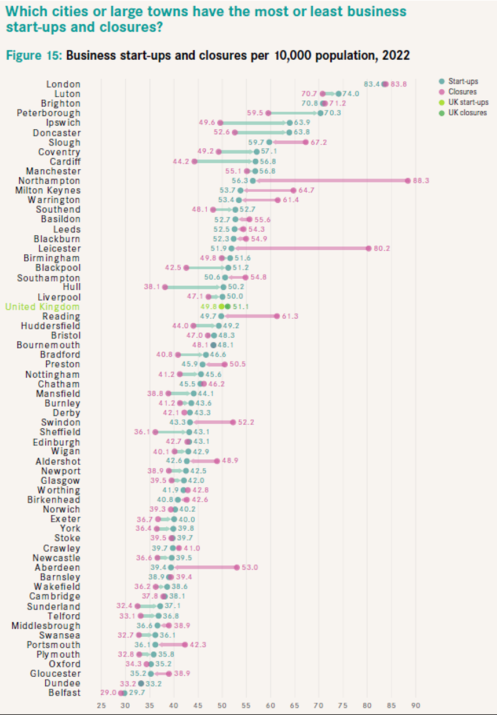

*Source – Centre for Cities Outlook Report 2024*

Luton is above average for new business growth and is expected to be the second-fastest growing city/large town in the whole of the UK, behind London.

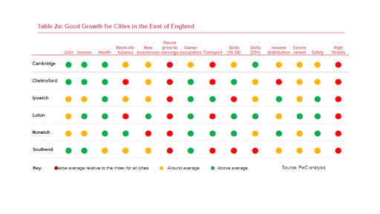

*Source – PwC (May 2023)*

**Business scale-ups:**

When employment growth of 20% or more is used to measure scale-ups, Luton has fewer businesses but much larger levels of employment and turnover than surrounding areas (25% more turnover than Milton Keynes, 3x more than Bedford and nearly 5x more than Central Bedfordshire).

The same can be said when using turnover growth of 20% or more to measure scale-ups, only Milton Keynes has a greater turnover than Luton (£3.8m compared to £2.3m).

*Source – High Growth Enterprises 2022 [ONS]*

**Business survival rates:**

Latest figures show that Luton businesses founded in 2019 have better 3 year survival rates when compared to the UK and England average, and other surrounding areas.

*United Kingdom 3 year survival percentage – 55.9%*

*England 3 year survival percentage – 55.9%*

*East of England 3 year survival percentage – 57.7%*

*Luton 3 year survival percentage – 57.1%*

*Central Bedfordshire 3 year survival percentage – 55.2%*

*Milton Keynes 3 year survival percentage – 49.8%*

*Bedford 3 year survival percentage – 56.3%*

However, businesses founded in 2017 have a lower 5 year survival rate percentage than UK, England, and East of England average. Nevertheless, Luton still outperforms some surrounding areas in this statistic.

*United Kingdom 5 year survival percentage – 39.6%*

*England 5 year survival percentage – 39.4%*

*East of England 5 year survival percentage – 39.2%*

*Luton 5 year survival percentage – 30.7%*

*Central Bedfordshire 5 year survival percentage – 25.6%*

*Milton Keynes 5 year survival percentage – 34.7%*

*Bedford 5 year survival percentage – 44.1%*

*Source – Business Demography 2022 [ONS]*

**Other business key messages:**

* Luton was in the top five of the UK’s largest cities & towns for jobs created since 2010. Luton tops the list for net new job creation percentage since 2010 with 30.5% (Source: Centre for Cities Outlook Report 2024)
* Luton had nearly 4 times more private sector jobs than public sector jobs in 2022 (Source: Centre for Cities Outlook Report 2024)
* Luton’s GVA annual contribution to the UK economy is £5.4bn (Source: ONS)
* 8,000 + businesses (Source: ONS)
* 106,000+ jobs (Source: ONS)
* London Luton Airport is the UK’s 5th largest airport, contributing £1.8bn to the UK economy with a further £1.5bn if the expansion is approved.