Business Case Lite – Luton Transformation Programme

Project Information
Project Title | Neighbourhood Working Model
Portfolio Tracker ref | Part-002
Current Stage / Gate: | Stage 0- Opportunity Identified
Project Sponsor | TBC
Project Lead | TBC
Transformation Theme | Partners
Contributory Transformation Theme(s) | Prevention and Early Intervention  Place  Resident Experience
Department and Team | Cross-cutting

LBC cannot continue to deliver services the way it has traditionally done so. Instead, it needs to better utilise community and neighbourhood assets (built assets, resources, people) to deliver more locally specific services within a neighbourhood or locality. A Neighbourhood Working Model encapsulates the community network approach to ensure that there is ‘somewhere to do, something to do and someone to see’.

This will support the council deliver against findings from the Marmot Report, Fuller Neighbourhood insights and 15-minute neighbourhoods. A Neighbourhood Working Model promotes system-wide working, as set out through the 2040 vision and can be the foundation for a radical change in public service delivery in Luton.

Scope of Project / Opportunity

In scope | Out of Scope
Community Hubs  Use of community centre assets  Family Hub programme  Asset Based Community Development  Social Prescribing Network  Delivery of Fairness Strategy  Community litter picking | N/A

Linked / Complementary OBCs
Resident Experience
Asset Strategy
CLC Estate
Town Centre Regeneration Programme
Homelessness

Objectives
- Transfer of service delivery of some universal services to community settings to be delivered through community-based council teams or devolved to community groups.
- Create places to raise issues, have one conversation and access a range of universal services.
- Promote Asset Based Community Development as a foundation to the neighbourhood working to unlock community and voluntary sector across the borough.
- Co-production of services with community leaders and residents.
- Delivery of recommendations and findings from Marmot report and Fuller insights through neighbourhood working.

Assessment of Current Position
- There are strands of work taking place across LBC, all with similar ambitions to promote community working:
  - Community Networks.
  - Community Hubs outline work.
  - Asset Based Community Development.
  - Fairness Strategy and other work completed by the Social Justice Unit.
  - Social Prescribing.
  - Grant funding.
- This work needs to be joined up to avoid duplication of work or savings or stretching of resources of teams across multiple initiatives.
- The Social Justice Unit leads community development work, with community leads across the borough. A new structure for this has already been completed.
- The Fairness Strategy sets out key principles and approaches to supporting communities that align to neighbourhood working:
  - Enabling communities and residents as providers of services to ensure access to and services for a super-diverse community.
  - Promotion of system working, community leaderships and partnership working.
- There is an understanding of existing areas of need through Fuller Neighbourhood insights.
- Initial thinking has been set out through Community Networks and Fuller Neighbourhood insights.
- The current use of community centres across the borough is inconsistent – some run by community groups, others run by LBC.
- Service provision across the borough is sporadic – but there are many hundreds of existing locations (community led, council led and partner led) that can be utilised to deliver the model. Community assets have already been mapped across the borough.

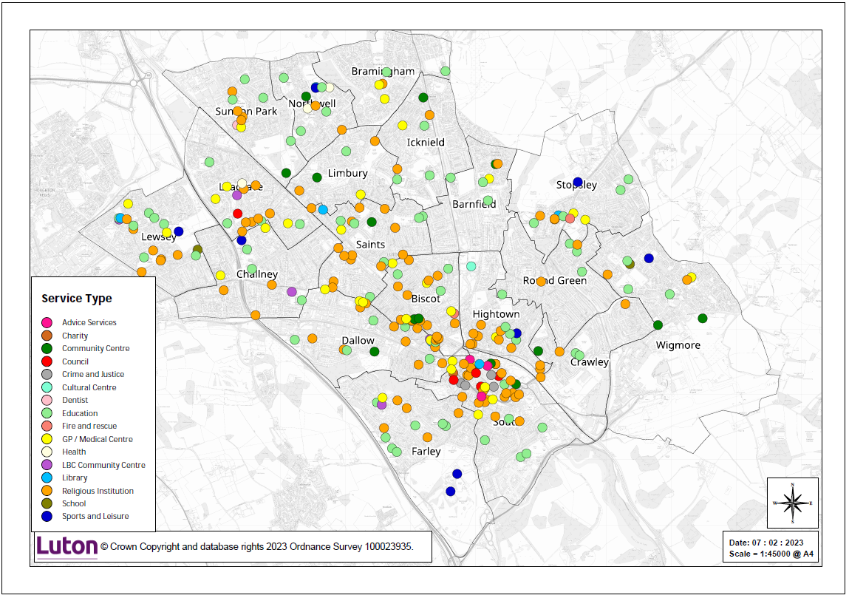

Type of community asset | Total
Religious Institution | 112
Education | 85
GP / Medical Centre | 35
Community Centre | 16
Sports and Leisure | 9
LBC Community Centre | 5
Library | 6
Council | 5
Crime and Justice | 4
Health | 3
Advice Services | 3
Fire and rescue | 2
Cultural Centre | 1
Charity | 1
Grand Total | 287

- Fuller Neighbourhood insights proposes a division of the borough into five areas that spreads the population and community assets relatively evenly.
- Similar models at other councils have had a broad range of services in scope, including libraries, social prescribing, children’s centres and adult and community learning. There has also been a push to promote information, advice and guidance services through community-based teams to reduce demand on council based contact centres and frontline teams.

Proposed Changes
- Introduce more locally specific services through community hubs and networks, asset based community development and social prescribing.
- Ensure this work is joined up and is conducted with the community’s best interests in mind.

Opportunity Qualification

Criteria | Rating
Financial Benefits | £ N/A
Effort / Easy of Implementation | 4
Impact (financial and non-financial) | 4

Note: This OBC sets out a way of working that joins together a series of initiatives taking place across the council. Combining the efforts of these initiatives will be difficult and effort to implement this approach across the borough is high. However, if backed, the impact can fundamentally shift the focus of service delivery in Luton and provide the foundations for many other savings initiatives proposed as part of the transformation programme and Luton 2040.

Financial Delivery

One off Investment required and savings
 | 23/24 | 24/25 | 25/26 | 26/27 | Total
One-off Investment | - | - | - | - | -
One-off Savings | - | - | - | - | -

Ongoing investments and savings
 | 23/24 | 24/25 | 25/26 | 26/27 | Total
Recurring Investment | - | - | - | - | -
Recurring Savings | - | - | - | - | -
Net Savings | - | - | - | - | -

Non-Cashable Benefits

Benefit | Description
Customer Experience | Services will be delivered within localities to specific needs.  Operating to 15-minute neighbourhood principles.
Employee Experience | Increasingly joined up working across system partners and reducing ‘handoffs’ of needs between partner organisations and the delivery of 2040 ambitions.
Productivity | Greater efficiency to meeting locality needs.
Social | Social inclusion and community cohesion (as set out in fairness strategy).  Enabling the delivery of recommendations of Marmot report.  Reduction in the reliance on low level social care services with demand managed within community settings.
Economic | Increased role of VCFSE across the borough, increased community capacity and capability and associated economic benefits of this (volunteer hours, skills development etc.).
Environmental | -

Resources and Stakeholders
The following summarises the team, and wider stakeholders involved in the project:
Direct Team | Social Justice Unit, Community Development, Property
Stakeholders – Governance and Decision Making | LBC leadership, Partnership stakeholder group
Stakeholders – Customers / Beneficiaries | Community Groups, Community Leaders, Residents
Stakeholders – Providers / Delivery Teams / Partners | Community Groups, Community Leaders, Health, Public Health, Police

Risks
The following top risks should be considered for this project:
Ref | Risk | Likelihood | Impact | Total | Mitigations
1 | If built assets are not available, then face to face service delivery cannot take place. | 2 | 5 | 10 | Align with CLC OBC under Place workstream. Determine availability of setting identified above.
2 | If community groups do not have capacity or capability to deliver, then demand remains with council services. | 3 | 3 | 9 | Capacity building through use of grant funding (see social investment OBC).  Focussed capability building within localities to meet need.
3 | If the council needs quicker results than can be delivered through this model, then momentum may reduce over time. | 2 | 4 | 8 | Maintain focus on model as a key deliverer of 2040 ambitions.  Engagement of stakeholder groups and co-production with residents and communities.

Critical dependencies, constraints, assumptions
- Dependency with the CLC OBC in regard to the use of built assets.
- Capacity and capability of community groups.

Timetable – Key Activities and Milestones

Stage / Gate target milestones | (Target) Date
Gate 0: Decision: Progress Opportunity | Oct 2023
Gate 1: Decision: Outline Business Case | Oct 2023
Gate 2: Decision: Full Business Case | Apr 2024
Gate 3: Decision: Investment Decision | Apr 2024
Gate 4: Decision: Go-Live / Handover to BAU | Apr 2025
Gate 5: Decision: Benefits Review Complete | Ongoing

Project Deliverable | Start | Finish
Confirmation of target services to devolve to locality areas | Oct 2023 | Mar 2024
Agreement of partnership team to deliver neighbourhood model | Jan 2024 | Mar 2024
Agreement of built assets required for model | Jan 2024 | Jun 2024
Assessment of community capacity and capability | Apr 2024 | Dec 2024
Assessment of LBC community teams’ resource requirements to deliver locality services | Apr 2024 | Dec 2024
Rollout of locality model | Apr 2025 | Ongoing

Approvals of this Savings Delivery Plan

Name | Role | Date Agreed
TBC | Project Sponsor | TBC

