**Luton Council Staff Survey 2022/23 – final report**

Contents

**Survey methodology** 4

**Scope of the report** 6

**Total fieldwork responses** 7

**Survey theme: Working at the council** 7

Question - How strongly do you agree or disagree with the following statements? 7

Question - My line manager: 9

Question - Your immediate team holds meetings, either face to face or online 11

**Survey theme - HR and Workforce Development** 11

Question - How strongly do you agree or disagree with the following statements about our values? 11

Question - I have the opportunity to develop my skills for professional growth 13

Question - If the opportunity presented itself, I would be likely to take up the following opportunities: 14

Question - Are you aware of the following Learning opportunities? And how likely would you be to use them? 14

**Survey theme - Your wellbeing** 15

Question - How happy are you at work? 1 being 'Happy', 10 being 'Unhappy' 15

Question - How manageable is your current workload? 1 being 'Completely Manageable, 10 being 'Completely Unmanageable'. 16

Question - How often do you feel stressed at work? 18

Question - Are you aware of the following support offered? And how likely would you be to use them? 19

**Survey theme - Cost of living** 20

Question - Are you worried about your financial situation over the next 12 months? 20

**Survey theme - New Ways of Working (Networked staff only)** 21

Question - Are you a hybrid worker? 21

Question - How often have you come into the workplace each week? 21

Question - Has your manager communicated a plan to you and your team about attendance in the workplace? 21

Question - When you are in the workplace, how much time does face to face individual or team collaboration take up in an average day? 22

**Survey theme - Luton 2040** 23

Question - Have you heard of the Luton 2040 vision? 23

Question - How much progress do you believe is being made towards Luton Council delivering Luton 2040? 23

Question - How much do you believe your role within the council contributes towards delivering the Luton 2040 vision? 24

**Survey theme - Internal Communications** 25

Question - How useful do you find the internal news section of the intranet? *(*Networked staff only*)* 25

Question - How useful do you find the weekly eBrief staff bulletin as a source of news and information? (Networked staff only) 26

Question - How do you hear about what is going on at the council? And how would you prefer to hear about what is going on? (Networked staff only) 26

Question - How do you currently hear about what is going on at the council? (Non-networked staff only) 27

Question - Do you have any access to the council email systems and intranet? 27

Question - Do you own, or have access to, a personal device? (Non-networked staff only) 27

Question - If you answered yes, would you be prepared to use a personal device to receive important information and updates from the council and management? (Non-networked staff only) 28

**Survey theme - Equality, Diversity and Inclusion** 29

Question - Do you feel the council is performing well in building a more equitable, diverse, and inclusive organisation? 29

Question - Do you feel you are able to be your true self at work? 29

Question - Are you aware of the EDI Coordinators and their role within your department? 31

Question - If you have any EDI issues, where do you go to communicate these? 31

**Purpose of the 2022 Staff Survey**

From 17 November- 23 December 2022, Luton Council undertook a survey of all its staff. Every two-three years, the council undertakes such a full survey to understand the state and attitudes of the organisation. The 2020 staff survey was cancelled due to the onset of the COVID-19 pandemic, meaning the 2022 iteration represented the first in more than five years.

Staff surveys empower an organisation to hold a mirror up to its senior leadership team. In order to be an effective council and a caring employer, it is important for its senior leadership to understand what working for Luton Council means for its staff, how it functions and what improvements can be made. One of the key principles of the staff survey is encouraging employees to provide honest, even candid feedback.

The 2022 staff survey measures the impact of one of the most dramatic changes to society and the organisation’s conduct in living memory. The COVID-19 pandemic, and the subsequent national restrictions that curtailed social interaction, fundamentally changed how the council operated. The majority of staff shifted to remote working, primarily from home. Although national restrictions were lifted entirely in 2021, Luton Council initiated its ‘New Ways of Working’ approach. A 60/40 split between remote and office work respectively was reccomended of non-frontline employees. In 2022, UK inflation rates rose to their highest level since 1981, placing an increased strain on the cost of living for council employees.

The 2022 staff survey measured the attitudes of the employees following these societal and organisational changes. In particular, the survey focused on staff wellbeing and how well ‘New Ways of Working’ have been embedded throughout the organisation.

Questions were divided along the following themes:

* Working at the Council
* HR and Workforce Development
* Employee Wellbeing
* Cost of Living
* New Ways of Working (Networked staff only)
* Luton 2040
* Internal Communications
* Equality, Diversity and Inclusion

Under each theme, a collection of questions were asked. Many of the questions were repeated from previous staff surveys to so we are able benchmark the responses over time if required.

# **Survey methodology**

Aims

For the staff survey to be of value, it must enable staff to provide honest feedback. Ensuring that the survey, and the means by which it was conducted, was transparent was essential. In compiling and producing the survey, the following three tests were set:

1. Anonymity – Does the survey’s conduct provide staff with confidence that the process would be anonymous, enabling honest feedback?
2. Accessibility – Are all staff able to understand and complete the survey?
3. Data – is the data we are collecting relevant and usable?

How the target audience were surveyed

Staff fell into two categories for the purposes of this survey: ‘networked’ and ‘non-networked’. Networked staff are defined as having access to their own work laptop, work mobile phone and are able to access the council’s digital network through a computer. Approximately 78% of staff are defined as networked. Non-networked staff do not have access to these resources.

Whilst most of the questions proposed for the networked staff survey would apply to non-networked staff, the difference in the working environment of these two types of employees required a bespoke survey for each group.

Two similar surveys were created. Whilst the two surveys are similar, surveys completed by networked staff asked questions about New Ways of Working and Internal Communications through digital channels.

Survey development

Questions covered in the survey were devised by a project team representing several council services. These included Communications, Digital Services, Luton 2040, Human Resources, Public Health, Social Justice, Technology and Transformation and Workforce Development.

Proposed questions were compiled from previous staff and pulse surveys, including the 2021 New Ways of Working survey. From September-October 2022, these questions were refined by the team. The Frontline Staff Task and Finish Group, responsible for improving working conditions and communications to non-networked members of staff, were then consulted regarding the optimum method of reaching these employees.

To incentivise participation, all participants who consented would be entered into a prize draw for three gift vouchers, each totalling £250.

A draft survey was proposed to the council’s senior leadership team in November 2022 for their agreement. Once obtained, the survey went live on 17 November 2022.

Questions

In total, 27 questions were asked in the survey of networked staff, 24 in the one for non-networked staff. Some questions were only available to respondents who provided a specific answer to a question. Such questions are noted throughout the report.

The surveys primarily asked questions that provided quantitative data, to ensure the results could be directly benchmarked against previous and future surveys. Qualitative questions were asked where we had no previous quantitative data to benchmark. For example, the Transformation and Technology team wanted to find out how hybrid working could be improved, which could not be benchmarked as the practice had only been introduced subsequent to the last staff survey.

In addition, the survey provided staff with an opportunity to comment on why they had selected certain options. Responses to questions that produced qualitative data were analysed by the Business Intelligence team, identifying key words and sentiments. Their analysis, detailed in this report, identifies trends that emerged from such analysis.

Distribution of the survey

The survey went live for a five week period, from 17 November- 23 December 2022.

Networked staff were able to complete the survey online, hosted on the council’s consultation portal. A link to survey distributed by all staff email, management cascade, the Intranet and eBrief.

Hard copies of the survey for non-networked staff were printed and posted to their home address. A Freepost return envelope was enclosed. For those who did not receive a hard copy by post, spare staff surveys were provided to managers across council owned buildings.

How the survey preserved anonymity

Anonymity is key to ensuring that respondents provide their honest feedback, to give an accurate portrayal of how an organisation functions. The 2022 staff survey balanced retaining anonymity with collecting enough data about respondents to identify trends.

How the data would be used was outlined to staff in all communications outputs relating to the staff survey. These outputs made it clear that individual results would only be visible to the Communications team, who conducted the survey, and officers in Business Intelligence when conducting analysis of qualitative responses. All communications outputs emphasised that any request from managers or directors for a detailed breakdown of any comments submitted would not be actioned.

The only data collected that could identify members of staff were the contact details asked of staff if they wished to enter the £250 prize draw. As outlined above, this data was only available to the Communications team. Contact details were immediately removed from the responses data once it was downloaded, to ensure nobody could be identified. Once the prize draw was conducted, this data was deleted.

# **Scope of the report**

The report provides an analysis of the questions asked under the following themes:

* Working at the Council
* HR and Workforce Development
* Employee Wellbeing
* Cost of Living
* New Ways of Working (Networked staff only)
* Luton 2040
* Internal Communications
* Equality, Diversity and Inclusion

As noted, there are instances where specific questions were only asked of networked or non-networked staff. These questions are highlighted in the report. Unless specified, questions combine data collected by networked and non-networked staff.

Responses to each question are detailed in the report. Headline figures are provided for each, providing an overview of responses across the organisation. Whilst the report identifies trends within the data, it does not provide recommendations regarding actions that should be taken by Luton Council.

# **Total fieldwork responses**

**Total responses**: 1,149.

**Responses from networked staff:** 1,063 responses out of 1942 networked staff. 54.7% completion rate.

**Responses from non-networked staff:** 86 responses out of 561 non-networked staff. 15.3% completion rate.

# **Survey theme: Working at the council**

## Question - How strongly do you agree or disagree with the following statements?

*Responses by networked staff*

|  |  |
| --- | --- |
| **Statement** | **Results – Percentage/Raw Number** |
| Statement 1 - If I saw unacceptable behaviour in the workplace, I would feel able to challenge it | Strongly agree: 27.3% (287)  Agree: 43.3% (455)  Neither agree or disagree: 14.95% (157)  Disagree: 11.04% (116)  Strongly disagree: 3.33% (35) |
| Statement 2- I am happy with the workplace culture at Luton Council | Strongly agree: 14.31% (150)  Agree: 43.89% (460)  Neither agree or disagree: 21.85% (229)  Disagree: 15.17% (159)  Strongly disagree: 4.77% (50) |
| Statement 3 - I have access to the information I need to do my job well | Strongly agree: 14.73% (155)  Agree: 51.9% (546)  Neither agree or disagree: 17.96% (189)  Disagree: 13.59% (143)  Strongly disagree: 1.80% (19) |
| Statement 4 -Working here makes me want to perform to the best of my ability | Strongly agree: 26.78% (281)  Agree: 49.28% (517)  Neither agree or disagree: 15.25% (160)  Disagree: 6.76% (71)  Strongly disagree: 1.9% (20) |
| Statement 5- My work gives me a feeling of personal accomplishment | Strongly agree: 24.02% (253)  Agree: 53.56% (564)  Neither agree or disagree: 14.15% (149)  Disagree: 6.45% (68)  Strongly disagree: 1.8% (19) |

*Responses by non-networked staff:*

|  |  |
| --- | --- |
| **Statement** | **Results – Percentage/Raw Number** |
| Statement 1 - If I saw unacceptable behaviour in the workplace, I would feel able to challenge it | Strongly agree: 22.09% (19)  Agree: 40.69% (35)  Neither agree or disagree: 22.09% (19)  Disagree: 10.46% (9)  Strongly disagree: 4.65% (4) |
| Statement 2 - I am happy with the workplace culture at Luton Council | Strongly agree: 24.7% (21)  Agree: 32.94% (28)  Neither agree or disagree: 23.52% (20)  Disagree: 10.58% (9)  Strongly disagree: 8.23% (7) |
| Statement 3 - I have access to the information and resources I need to do my job well | Strongly agree: 24.41% (21)  Agree: 34.88% (30)  Neither agree or disagree: 22.09% (19)  Disagree: 8.13% (7)  Strongly disagree: 10.46% (9) |
| Statement 4 - Working here makes me want to perform to the best of my ability | Strongly agree: 29.41% (25)  Agree: 40% (34)  Neither agree or disagree: 20 (17)  Disagree: 7.05% (6)  Strongly disagree: 3.52% (3) |
| Statement 5- My work gives me a feeling of personal accomplishment | Strongly agree: 30.23% (26)  Agree: 43.02% (37)  Neither agree or disagree: 19.76% (17)  Disagree: 2.32% (2)  Strongly disagree: 4.65% (4) |

**Summary of findings**

A majority agreed with the each of the statements. Statement 4 received the strongest agreement from networked staff (75%) whilst non-networked staff agreed with Statement 5 more than any other (73%). Only 65% of networked staff said that they have access to the information they need to do their job well. The figure decreases to 58% amongst non-networked staff.

Whilst below the average for other organisations, 30% of networked respondents also reported that they are unhappy with the workplace culture at Luton Council.

## Question - My line manager:

*Responses by networked staff*

|  |  |
| --- | --- |
| **Statement** | **Results** |
| Statement 1 - Empowers me to make decisions | Strongly agree: 34.69% (364)  Agree: 38.13% (400)  Neither agree or disagree: 16.2% (170)  Disagree: 7.5% (79)  Strongly disagree: 3.43% (36) |
| Statement 2 - Enables me to confidently discuss personal wellbeing | Strongly agree: 37.63% (397)  Agree: 36.77% (388)  Neither agree or disagree: 13.93% (147)  Disagree: 7.29% (77)  Strongly disagree: 4.36% (46) |
| Statement 3 -Discusses my career progression and development | Strongly agree: 21% (221)  Agree: 32.31% (340)  Neither agree or disagree: 22.9% (241)  Disagree: 15,11% (159)  Strongly disagree: 8.65% (91) |
| Statement 4 - Regularly talks to me about my learning and development, for example, check ins. | Strongly agree: 30.68% (324)  Agree: 35.22% (372)  Neither agree or disagree: 16.38% (173)  Disagree: 11.17% (118)  Strongly disagree: 6.53% (69) |
| Statement 5 - Acknowledges when I have done my job well | Strongly agree: 42.05% (442)  Agree: 34.53% (363)  Neither agree or disagree: 12.84% (135)  Disagree: 6.85% (72)  Strongly disagree: 3.71% (39) |
| Statement 6 - Provides the support I need to do my job well | Strongly agree: 39.16% (414)  Agree: 35.76% (378)  Neither agree or disagree: 14.94% (158)  Disagree: 6.81% (72)  Strongly disagree: 3.31% (35) |
| Statement 7 - Communicates regularly with me | Strongly agree: 43.04% (455)  Agree: 39.6% (419)  Neither agree or disagree: 9.27% (98)  Disagree: 5.48% (58)  Strongly disagree: 2.55% (27) |

*Responses by non-networked staff*

|  |  |
| --- | --- |
| **Statement** | **Results** |
| Statement 2 - Enables me to confidently discuss my personal wellbeing | Strongly agree: 31.39% (27)  Agree: 29.06% (25)  Neither agree or disagree: 16.47% (14)  Disagree: 11.62% (10)  Strongly disagree: 11.62% (10) |
| Statement 3 - Discusses my career progression and development | Strongly agree: 18.82% (16)  Agree: 20% (17)  Neither agree or disagree: 24.7% (21)  Disagree: 16.47% (14)  Strongly disagree: 20% (17) |
| Statement 4 - Regularly talks to me about my learning and development, for  example, check-ins | Strongly agree: 20.93% (18)  Agree: 24.41% (21)  Neither agree or disagree: 20.93% (18)  Disagree: 16.47% (14)  Strongly disagree: 17.44% (15) |
| Statement 5 - Acknowledges when I have done my job well | Strongly agree: 29.06% (25)  Agree: 34.88% (30)  Neither agree or disagree: 10.46% (9)  Disagree: 10.46% (9)  Strongly disagree: 15.11% (13) |
| Statement 6 - Provides the support I need to do my job well | Strongly agree: 29.06% (25)  Agree: 30.23% (26)  Neither agree or disagree: 22.09% (19)  Disagree: 9.3% (8)  Strongly disagree: 9.3% (8) |
| Statement 7 - Communicates regularly with me | Strongly agree: 31.39% (27)  Agree: 33.72% (29)  Neither agree or disagree: 11.62% (10)  Disagree:10.46% (9)  Strongly disagree: 12.79% (11) |

**Summary of results**

Agreement with all the statements is higher amongst networked staff than non-networked staff. Despite a majority responding otherwise, 36% of respondents did not agree that their manager provided regular check-ins. Furthermore, only 53% of networked staff said that they discuss progression and personal development with their managers. This decreases to 38% amongst non-networked staff, with 36% disagreeing.

Communications between managers and teams were identified as working well by respondents, with support provided to them in order to do their job.

## Question - Your immediate team holds meetings, either face to face or online

*Responses by networked staff*

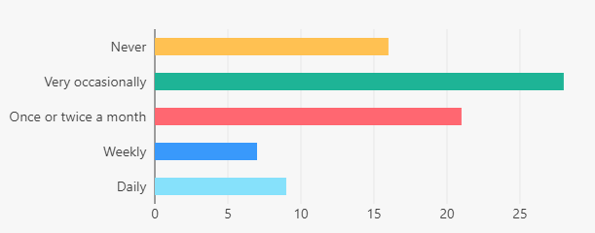

*Responses by non-networked staff*

**Summary of results**

A majority of staff report that their team holds meetings either very occasionally or once/twice a month. A significant portion of staff report that they never have team meetings, more than those who claim to have meetings weekly or daily. There is little variance between networked and non-networked staff.

# **Survey theme - HR and Workforce Development**

## Question - How strongly do you agree or disagree with the following statements about our values?

*Responses by networked staff*

|  |  |
| --- | --- |
| **Statement** | **Results** |
| Statement 1 - The council’s values are demonstrated in the way the organisation is led | Strongly agree: 11.53% (122)  Agree: 40.07% (424)  Neither agree or disagree: 29.11% (308)  Disagree: 12.57% (133)  Strongly disagree: 4.82% (51)  Not sure: 1.89% (20) |
| Statement 2: The council’s values are reflected in the way that colleagues behave | Strongly agree: 10.02% (106)  Agree: 40.96% (433)  Neither agree or disagree: 29.32% (310)  Disagree: 14.47% (153)  Strongly disagree: 4.16% (44)  Not sure: 1.04% (11) |
| Statement 3: The council’s values are reflected in the way that decisions are made | Strongly agree: 7.6% (80)  Agree: 34.69% (365)  Neither agree or disagree: 34.31% (361)  Disagree: 15.49% (163)  Strongly disagree: 5.79% (61)  Not sure: 2.09% (22) |
| Statement 4: The council’s values are reflected in the way that elected members behave | Strongly agree: 6.08% (64)  Agree: 26.42% (278)  Neither agree or disagree: 42.68% (449)  Disagree: 12.64% (133)  Strongly disagree: 4.75% (50)  Not sure: 7.41% (78) |

*Responses by non-networked staff*

|  |  |
| --- | --- |
| **Statement** | **Results –Percentage/Raw number** |
| Statement 1 - The council’s values are demonstrated in the way the organisation is led | Strongly agree: 15.6% (13)  Agree: 26.50% (22)  Neither agree or disagree: 50.43%(36)  Disagree: 7.22% (6)  Strongly disagree: 7.22% (6)  Not sure: (0) |
| Statement 2- The council’s values are reflected in the way that colleagues behave | Strongly agree: 18.07% (15)  Agree: 39.75% (33)  Neither agree or disagree: 28.91% (24)  Disagree: 6.02% (5)  Strongly disagree: 7.22% (6)  Not sure: (0) |
| Statement 3- The council’s values are reflected in the way that decisions are made | Strongly agree: 19.51% (16)  Agree: 32.92% (27)  Neither agree or disagree: 32.92% (27)  Disagree: 6.09% (5)  Strongly disagree: 7.31% (6)  Not sure: 1.21% (1) |

**Summary of results**

Whilst a majority agreed with statements 1, 2 and 3, the majorities were slim. Only 52% agreed that colleagues behaved in a way that upheld the values whilst 53% agreed that the values are embodied in the way the organisation is led.

A majority of respondents were unable to agree with statement 4, that council values were reflected in the behaviour of elected members.

## Question - I have the opportunity to develop my skills for professional growth

*Responses by networked staff*

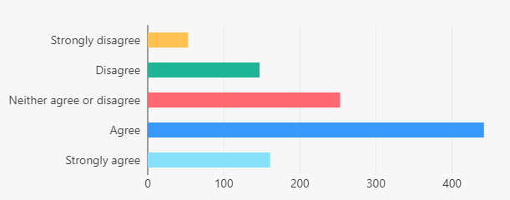

*Responses by non-networked staff*

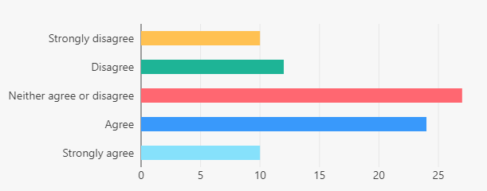

**Summary of results**

There is a clear divide between networked and non-networked staff regarding opportunities for personal development. Although most networked staff were likely to agree with the statement, the majority of non-networked staff did not.

## Question - If the opportunity presented itself, I would be likely to take up the following opportunities:

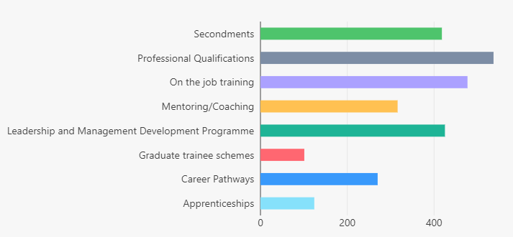*Responses from staff*

Question - Are you aware of the following Learning opportunities? And how likely would you be to use them?

**Summary of results**

Schemes that non-networked staff are already aware of are less likely to be used. Apprenticeships are the most notable example. The reverse is true of schemes that staff were less aware of, such as Career Pathways.

# **Survey theme - Your wellbeing**

## Question - How happy are you at work? 1 being 'Happy', 10 being 'Unhappy'

*Responses by networked staff*

*Responses by non-networked staff*

**Summary of results**

The average score was 4.54 out of 10 for networked staff, 3.88 for non-networked staff.

## Question - How manageable is your current workload? 1 being 'Completely Manageable, 10 being 'Completely Unmanageable'.

*Responses by networked staff*

*Responses by non-networked staff*

**Summary of results**

The average score was 5.08 out of 10 for networked staff, 3.9 for non-networked staff.

## Question - How often do you feel stressed at work?

*Responses by networked staff*

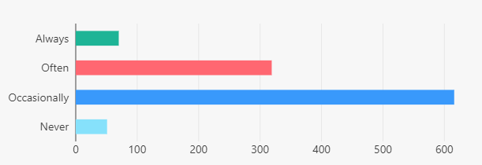

*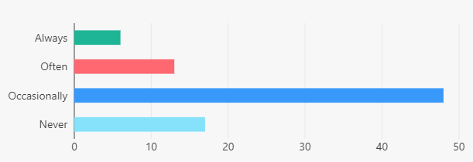Responses by non-networked staff*

**Summary of results**

The majority of respondents in most departments report occasional stress at work. However 36% say they ‘Often’ or ‘Always’ feel stressed at work, with the number rising for networked staff. By contrast, non-networked staff were more likely to report ‘Never’ feeling stressed at work.

## Question - Are you aware of the following support offered? And how likely would you be to use them?

*Responses by networked staff*

# **Survey theme - Cost of living**

## Question - Are you worried about your financial situation over the next 12 months?

*Responses by networked staff*

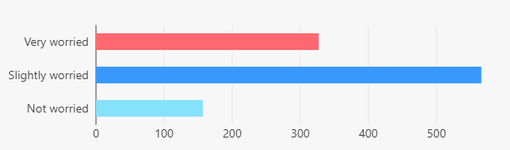

*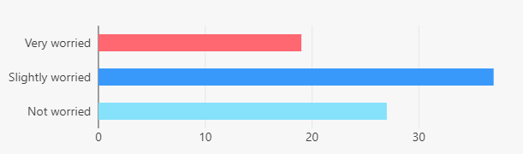Responses by non-networked staff*

**Summary of results**

On average, 84% of staff stated that they were at least slightly worried about their financial situation over the next 12 months. Furthermore, 31% of staff on average stated that they were ‘Very worried’ about their financial situation. Networked staff were more likely to report feeling worried than their non-networked colleagues.

# **Survey theme - New Ways of Working (Networked staff only)**

## Question - Are you a hybrid worker?

*Staff responses*



## Question - How often have you come into the workplace each week?

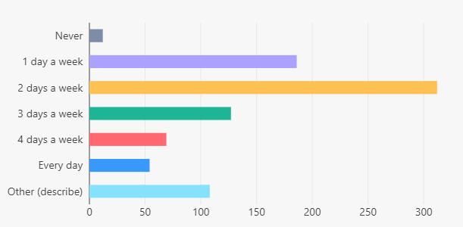*Responses by networked staff*

**Summary of results**

The majority of respondents stated that they came in to the office 1-2 days a week. A significant portion opted to describe their remote/in office balance, as explained above.

## Question - Has your manager communicated a plan to you and your team about attendance in the workplace?

*(Question available to those who answered ‘Yes’ to the question ‘Are you a hybrid worker?’)*

*Responses by networked staff*

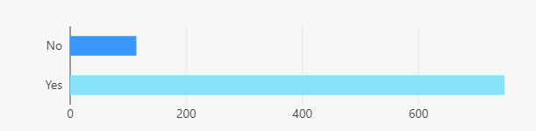

**Summary of results**

Across the organisation, the responses to this question suggest that an overwhelming majority of managers have communicated a plan regarding regular attendance in work.

## Question - When you are in the workplace, how much time does face to face individual or team collaboration take up in an average day?

*(Question available to those who answered ‘Yes’ to the question ‘Are you a hybrid worker?’)*

*Responses by networked staff*

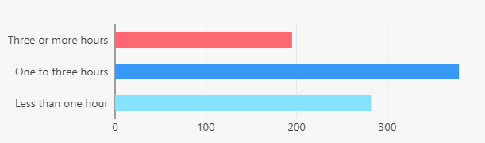

**Summary of results**

Whilst the majority of employees are required to undertake 7-8 hours of work a day, 80% of Luton Council staff report that they spend less than half of their time in the office collaborating face-to-face with colleagues. 33% of respondents reported spending less than one hour collaborating face-to-face with colleagues, which rose to 44% for those who spend one to three hours collaborating face-to-face in the office.

# **Survey theme - Luton 2040**

## Question - Have you heard of the Luton 2040 vision?

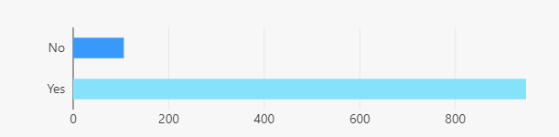*Responses by networked staff*

*Responses by non-networked staff*

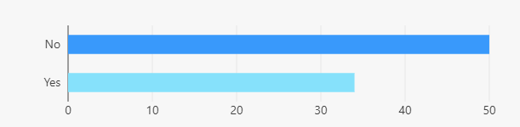

**Summary of results**

There is a clear split between networked and non-networked staff in response to this question. Whilst the overwhelming majority of networked staff have heard of Luton 2040, most non-networked staff who responded claim not to have heard of the vision.

## Question - How much progress do you believe is being made towards Luton Council delivering Luton 2040?

*(Question available to those who answered ‘Yes’ to the question ‘Have you heard of the Luton 2040 vision?’)*

*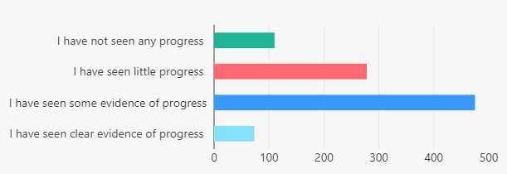Responses by networked staff*

*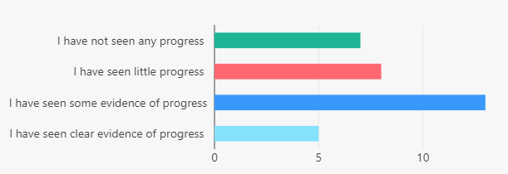Responses by non-networked staff*

**Summary of results**

A narrow majority of staff believe that at least some progress has been made towards Luton 2040. Responses from networked staff were more likely to indicate that they had seen at least some progress. Non-networked staff were more likely to indicate that no progress has been seen, building on the theme that more staff without network access are unaware of Luton 2040.

## Question - How much do you believe your role within the council contributes towards delivering the Luton 2040 vision?

*(Question available to those who answered ‘Yes’ to the question ‘Have you heard of the Luton 2040 vision?’)*

*Responses by networked staff*

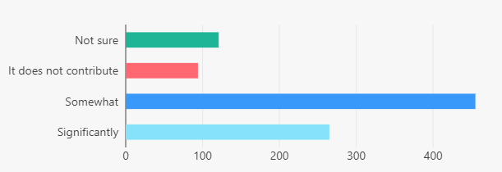

*Responses by non-networked staff*

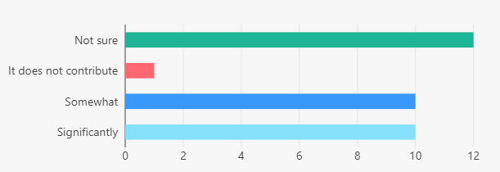

**Summary of results**

An overwhelming majority of networked staff responded by stating that they had at least some awareness of how Luton 2040 related to their role. A high proportion of non-networked staff responded by stating they were ‘Not Sure’, although those who said that ‘It does not contribute’ were low.

# **Survey theme - Internal Communications**

## Question - How useful do you find the internal news section of the intranet? *(*Networked staff only*)*

*Responses by networked staff*

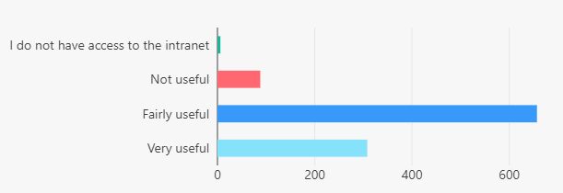

**Summary of results**

A majority of staff find that the intranet is a useful source of information.

## Question - How useful do you find the weekly eBrief staff bulletin as a source of news and information? (Networked staff only)

*Responses by networked staff*

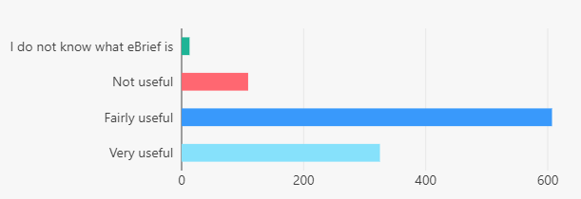

**Summary of results**

A majority of respondents found that eBrief was a useful source of information.

## Question - How do you hear about what is going on at the council? And how would you prefer to hear about what is going on? (Networked staff only)

*Responses by networked staff*

**Summary of results**

Respondents stated that eBrief, email or intranet is the most common channel by which they receive information. 1:1s/team meetings/briefings from manager was narrowly in second, although these two channels exchanged places when staff stated which channel they preferred to hear information through. Those who heard news through external and social media also responded by stating they would not wish to hear such news through this channel.

## Question - How do you currently hear about what is going on at the council? (Non-networked staff only)

*Responses by non-networked staff*

Question - Do you have any access to the council email systems and intranet? (Non-networked staff only)

*Responses by non-networked staff*

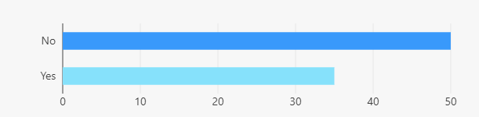

## Question - Do you own, or have access to, a personal device? (Non-networked staff only)

*Responses by non-networked staff*

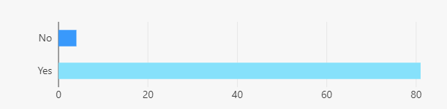

## Question - If you answered yes, would you be prepared to use a personal device to receive important information and updates from the council and management? (Non-networked staff only)

*Responses by non-networked staff*

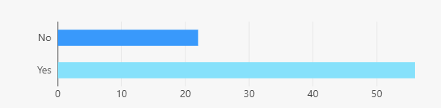

# **Survey theme - Equality, Diversity and Inclusion**

## Question - Do you feel the council is performing well in building a more equitable, diverse, and inclusive organisation?

*Responses by networked staff*

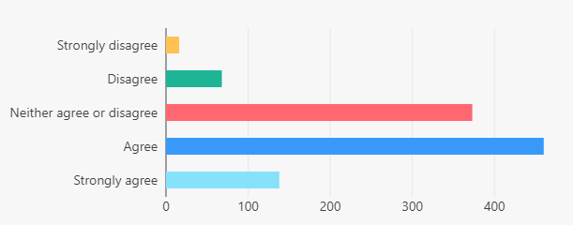

*Responses by non-networked staff*

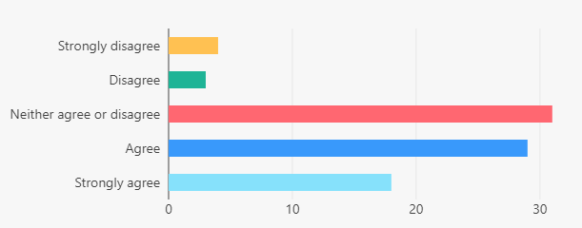

**Summary of results**

Whilst a majority of staff agree that Luton Council is performing well in this area, a signifcant minority are unsure whether they would disagree either. The theme is more pronounced amongst non-networked staff, where ‘Neither agree or disagree’ was the most selected category.

## Question - Do you feel you are able to be your true self at work?

*Responses by networked staff*

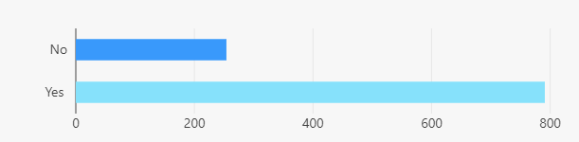

*Responses by non-networked staff*

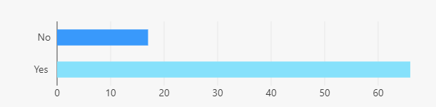

**Summary of results**

A large majority of respondents state that they can be their true selves at work across the organisation.

## Question - Are you aware of the EDI Coordinators and their role within your department?

*Responses by networked staff*

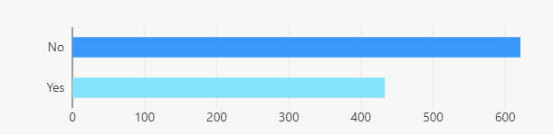

*Responses by non-networked staff*

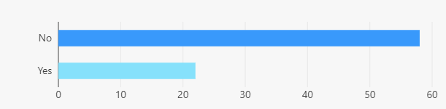

**Summary of results**

A majority of staff are unaware of EDI coordinators and their role in the department. Non-networked staff are less likely to be aware of EDI co-ordinators than networked staff.

## Question - If you have any EDI issues, where do you go to communicate these?

*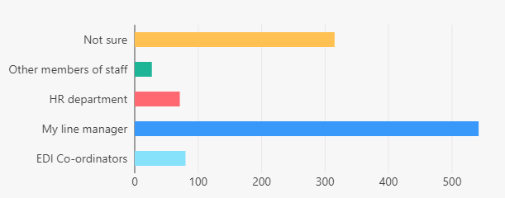Responses by networked staff*

*Responses by non-networked staff*

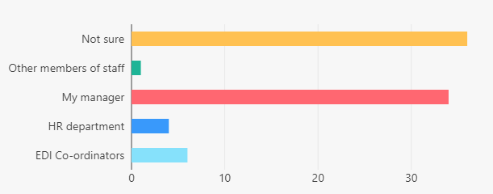

**Summary of results**

The results reflect those provided to the question ‘Are you aware of the EDI Coordinators and their role within your department?’ with the manager being the point of contact for most of those who have EDI concerns. Among non-networked staff, the most common category was ‘Not Sure’. Those who were less knowledgeable of their EDI coordinators were more likely to reach out to their manager.