**Terms of Reference for the development of the**

**Luton Economic Strategy 2025- 2032**

**Draft for discussion/ input from the Inclusive Economy Board**

**Introduction and Project Background**

In October 2020, we launched the Luton 2040 vision and Inclusive Economy Strategy for the town. We, like all towns and cities across the UK could not have foreseen what would shortly be coming our way with the devastating impacts of the pandemic and, more recently, the cost of living crisis and the war in Ukraine. Luton was the second most impacted place by COVID, with Centre for Cities citing Luton as having the 7th highest number of furloughed workers, 32,000 jobs at risk and the 8th highest claimant counts for cities and large towns in the UK. However, over the last three years, the town has worked harder than ever, and we are seeing significant progress being made.

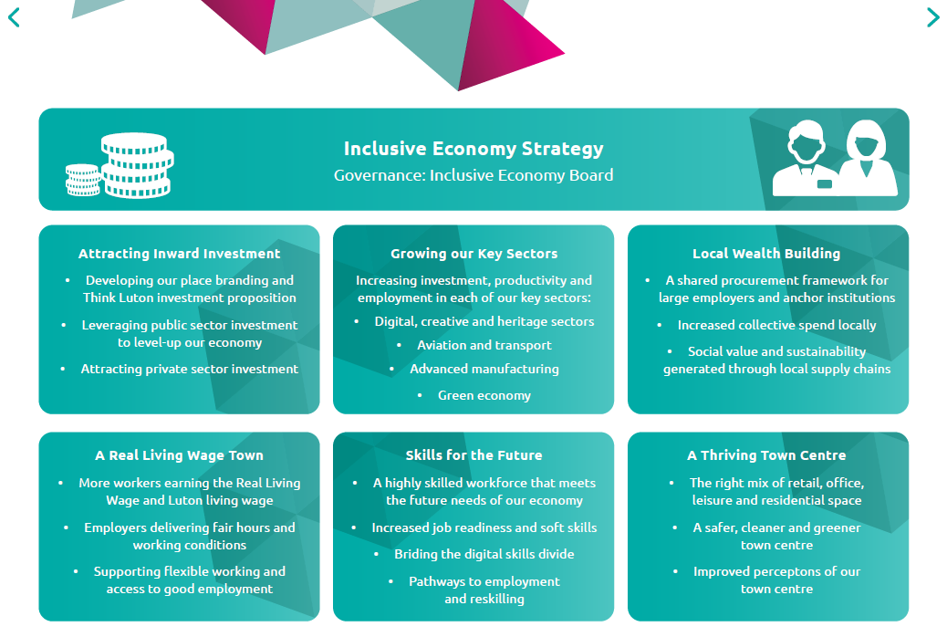

**The Inclusive Economy Strategy on a page (Source: Luton 2040 vision).**

There is already much good work underway. We officially launched the Town Centre Master plan in 2021 and secured £20million from the Levelling Up Fund towards the £140million Stage project. We opened Hat Gardens in Late 2022, Luton Town Football Club has been promoted to the premier league and confirmed £600 million investment in a new town centre stadium and our University Barnfield Campus College officially opened their brand-new £25m campus and work is now underway for the second phase. The University of Bedfordshire made an investment of £300k into a new data visualisation suite. They also supported 26 non-levy employers to have apprentices and a further 150 people engaged with UoB’s Pathways to Recovery programme for self-employment.

Luton Airport which is strategic and regionally significant economic asset for Luton supports a critical supply of jobs and economic activity in the town, the counties of Bedfordshire, Buckinghamshire and Hertfordshire, and beyond. In 2019, the airport supported over 28,400 jobs (generating £1.8 billion in GDP) across the UK, when its supply chain is included. They recently submitted their Development Consent order to seek approval to grow to 32m passengers.

Our key development sites continue to progress at pace, with phase 3 of the Butterfield site underway. Planning has been approved for both the Junction 10 site (Wrenbridge) and Osborne Road site (Prologis). Luton Rising has now submitted the DCO – include headline economic benefits;

We launched our employment and skills strategy in March 2022 and is now in its third year of delivery. Luton had the highest net new job creation in British cities and large towns between 2010 and 2022, even ahead of London. Luton also has the second-highest business start-up rate in the country in 2023, along with the 5th highest proportion of private-sector jobs.

All of this work provides a strong base for further strengthening and growing our economy in future years.

The 2040 vision has been refreshed and we are now post-pandemic, and alongside the work already underway, it is an opportune time to rethink and refresh the inclusive economy strategy and economic evidence base. In addition, we want to ensure a stronger, more integrated approach to inclusive and sustainable economic growth through our commitments to net zero objectives, improved health and well-being for our residents and tackling inequalities and Luton as a child-friendly town.

**Project objectives, including opportunity and challenges**

As the Luton economy grows, we want to ensure that the future of our town is more inclusive, more productive, more competitive, more and better jobs and where our residents are healthier and our town greener so that everyone benefits from the economic growth and increased well-being we are aiming to achieve.

Since the last update to the Strategy in 2020, there has been a significant change to the economic, political, social and environmental landscape, and this new Luton Economic Strategy 2025 - 2030 re-affirms our commitment to working together through the Inclusive Economy Board to co-produce a refreshed strategy and delivery plans.

The Luton Economic Strategy will focus on the next five years (2025-2032) and align with our vision as we journey to 2040. The Inclusive Economy Board will oversee the development of the Economic Strategy and detailed delivery plan(s). The updated Strategy will provide a framework for how best to deliver growth that benefits all our citizens and communities.

We will want to use this Strategy to engage those in Whitehall on what can be achieved and need the government to step up and provide public sector funding right across the system. A growing, inclusive and sustainable economy is not just good for Luton but good for the wider region and nationally.

The Inclusive Growth Service will manage the project, including project planning, stakeholder planning and management, evidence base, proposals and recommendations for the Board to consider.

An outline delivery roadmap is set out below.

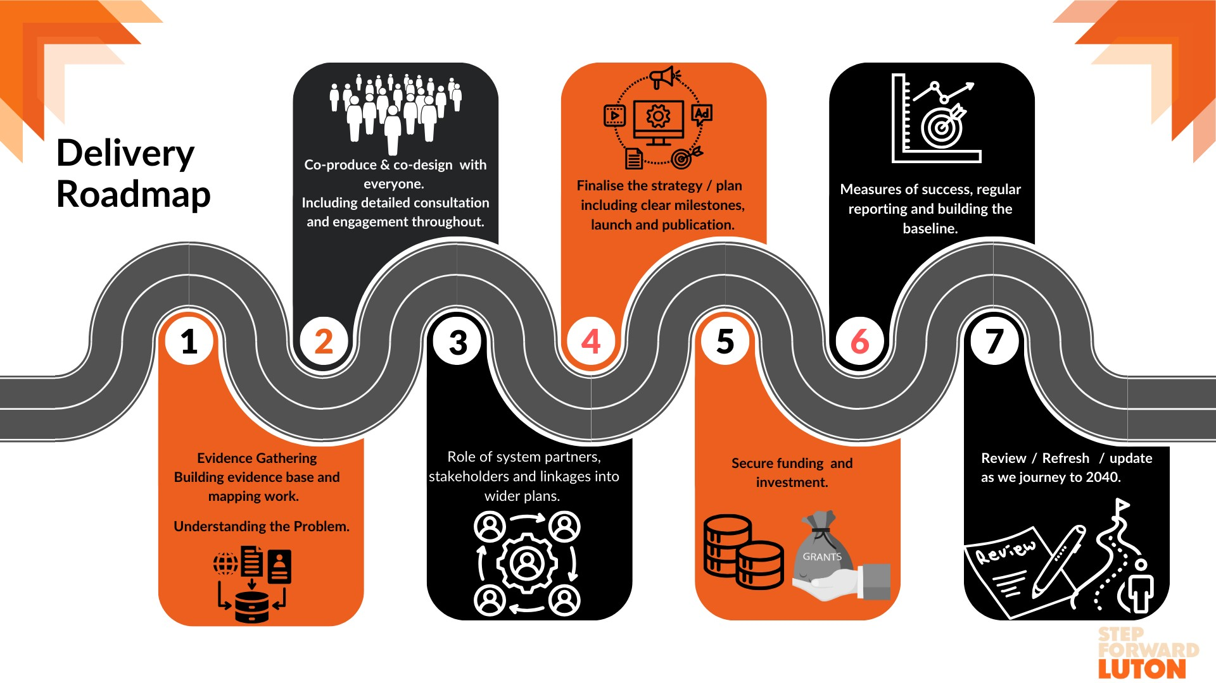

The timeline for the project is as follows:

|  |  |
| --- | --- |
| **Item** | **Timescale** |
| Sign off on the terms of reference for the IE refreshed Strategy | 7th February 2024 |
| Commission the economic study and evidence base. | Feb – March 2024 |
| Stakeholder engagement to get underway | June – October 2024 |
| First proposed draft strategy and stakeholder report back | Late October 2024 |
| Begin formal Member Process and sign off with the Executive | November – January 2025 |
| Formal launch of new strategy and implementation plan | Feb 2025 |

Inclusive growth is economic growth that is distributed fairly across society and creates opportunities for all, so it is fundamental that the Luton Economy Strategy and delivery plans are able to engage with a wide and varied audience ranging from private sector organisations to our residents.

The Strategy will have a number of plans, delivery plans and KPIs that sit underneath it, including:

* Skills and Employability Plan
* Local Wealth Building and Anchors Framework
* Net zero roadmap
* Inward Investment Plan, including strategic regeneration
* Visitor economy Plan, including night-time economy
* Town Centre Plan

Each of these plans either already has its own delivery groups or will form groups that will drive these plans. However, they will report back to the Inclusive Economy Board, and this will be set out as part of the Inclusive Economy Project Plan and agreed Programme Plan for the Inclusive Economy Board. This will also include town-wide KPIs, an annual report and an updated economic profile for the town.

The Strategy will galvanise partners and ensure we are aligned around our 2040 vision. Our system partners approach will be fundamental to delivering the Inclusive Economy Strategy, which is focused on supporting one another to make Luton the best it can be, sharing ideas and learning, working in genuine partnership, being ambitious about our collective social and environmental impact, and organisations sharing their resources and assets as we work towards common goals.

The Strategy will create a direction of travel for the next five years, which will help to build confidence against a backdrop of economic uncertainty but will capitalise on the £5bn transformation programme, Luton Town being in the Premier League and the work we are doing through Airport Expansion and wider town regeneration.

We want to use the Strategy to highlight the role that businesses have to play in providing good jobs and supporting communities and that the public sector has to play in being more enterprising and efficient in delivering better services.

A new delivery framework will enable us to realise our ambitions. Luton contributes more than £5bn per year to the UK Economy, and with its unique location, broad-based economy, diverse population, and reputation for collaboration and as one of the most entrepreneurial places in the country has enabled Luton to reimagine itself and diversify. A growing economy will lead to more investment for the town. However, we need to remain competitive, embrace innovation and new and emerging technologies including Generative Artificial Intelligence and other technologies.

**Methodology and next steps**

* Establish the economic evidence base to identify the “Grand Challenges” and opportunities for successful economic growth – providing a complete and analytical assessment of Luton’s economic, social and demographic conditions/
* Review existing strategies / plans, actions etc. to validate at a high level the extent to which they meet are economic growth ambitions
* National and regional strategic context
* Develop the ‘mission statements’ – our objectives
* Stakeholder consultation
* Articulating and quantifying key outcomes and actions, including performance metrics and KPIs to measure progress and impact
* Develop an action plan for the purpose of implementing the strategy

Traditional economic development approaches have not worked as well as hoped for in many places due in large part to economic, social and health & well-being policy and strategy implementation operating separately. Developing and successfully implementing the Luton Economic Strategy 2025 – 2030 requires a multi-agency approach. The Inclusive Economy Board represents a guiding coalition – a partnership that has a common purpose, to do more and do it better so that the benefits of a stronger and growing economy are widely shared across Luton in line with our 2040 vision.

Alongside the project plan for the Inclusive Economy Strategy, there will be project plans for each subproject / plan that sit underneath so the Board has full oversight of all work streams. It will also set out a clear stakeholder plan, including the key milestones for the IEB. The Board may feel it useful to implement a Task and Finish or sub group to ensure the project is able to move at pace.

For the collection of data, various sources will be used, including the council's observatory, the Social Progress Index, and the Ox CAM observatory and partners will also be requested to share data to enable us to build a clear evidence base, set the right KPIs and be able to measure success.

The IEB are asked to sign off the approach and methodology.